# EX.NO:1A ARRAY IMPLEMENTATION OF STACK ADT AIM:

Aim is to write a program in C to implement the stack ADT using array concept that performs all the operations of stack.

## DESCRIPTION:

A stack data structure can be implemented using one dimensional array. But stack implemented using array, can store only fixed number of data values. This implementation is very simple, just define a one dimensional array of specific size and insert or delete the values into that array by using LIFO principle with the help of a variable 'top'. Initially top is set to -1. Whenever we want to insert a value into the stack, increment the top value by one and then insert. Whenever we want to delete a value from the stack, then delete the top value and decrement the top value by one.

**ALGORITHM:**

STEP 1: Define an array to store the element. STEP 2: Get the users’ choice.

STEP 3: If the option is 1 perform creation operation and goto step4.

If the option is 2 perform insertion operation and goto step5. If the option is 3 perform deletion operation and goto step6. If the option is 4 perform display operation and goto step7.

STEP 4: Create the stack. Initially get the limit of stack and the get the items. If the limit of stack is exceeds print the message unable to create the stack.

STEP 5: Get the element to be pushed. If top pointer exceeds stack capacity. Print Error message that the stack overflow. If not, increment the top pointer by one and store the element in the position which is denoted by top pointer.

STEP 6: If the stack is empty, then print error message that stack is empty. If not fetch the element from the position which is denoted by top pointer and decrement the top pointer by one

STEP 7: If the top value is not less than the 0 the stack is display otherwise print the message “stack is empty”.

STEP 8: Stop the execution.

DEPARTMENT OF COMPUTER SCIENCE AND ENGINEERING PEC

# PROGRAM:

CS8381 DATA STRUCTURES LABORATORY

**#include<stdio.h> #include<conio.h> #define max 20**

# int opt, a[20],i,top=0,n; void main()

**{**

# void create(),push(),pop(),disp(); int wish;

**do**

# {

**clrscr(); printf("\nMENU");**

# printf("\n1.Create\n2.Push\n3.pop\n4.Display\n5.Exit\n"); printf("\nEnter your option");

**scanf("%d",&opt); switch(opt)**

# {

**case 1:create();break; case 2:push();break; case 3:pop();break; case 4:disp();break; case 5:exit(0);**

# }

**printf("\nDo u want to cintinue(1/0):"); scanf("%d",&wish);**

# }while(wish==1);} void create()

**{**

# printf("\n Enter the limit of stack"); scanf("%d",&n);if(n<max)

DEPARTMENT OF COMPUTER SCIENCE AND ENGINEERING PEC

**{**

# }

**else**

# printf("\nEnter the items"); for(i=0;i<n;i++) scanf("%d",&a[i]);

**top=n-1;**

# printf("\nUnable to create the stack");

**}**

# void push()

**{**

# int x; if(top<max){

**printf("\nEnter the element to be pushed:"); scanf("%d",&x);**

# top=top+1; a[top]=x; n=top;

**}**

# else

**printf("\n Stack is full");**

# }

**void pop()**

# {

**if(top<0)**

# printf("\n Stack is empty"); else

**{**

# printf("\nThe element popped is %d",a[top]); top=top-1;

**n=top;**

DEPARTMENT OF COMPUTER SCIENCE AND ENGINEERING PEC

DEPARTMENT OF COMPUTER SCIENCE AND ENGINEERING PEC

# }}

**void disp()**

# {

**if(top<0)**

# printf("\n Stack is empty"); else

**{**

# printf("\n The elements in the stack are:"); for(i=top;i>=0;i--)

**printf("\n%d",a[i]);**

# }

**}**

**OUTPUT:**

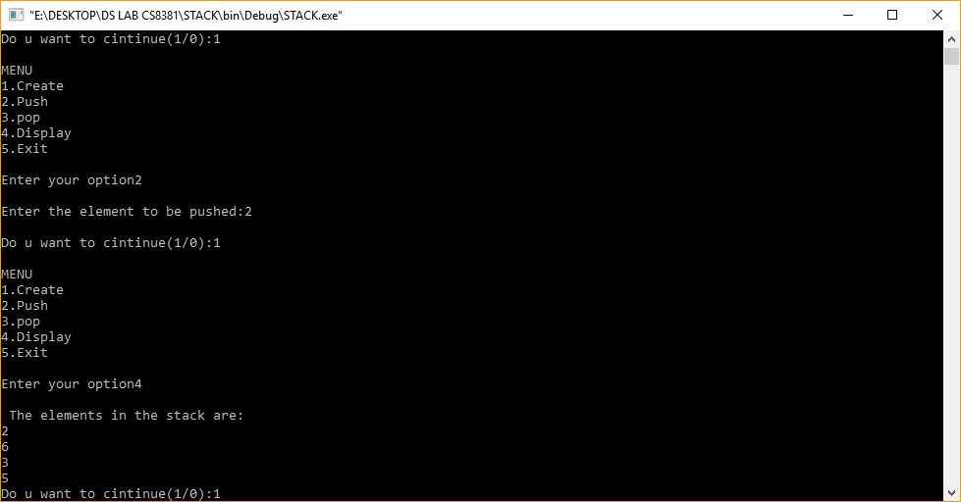

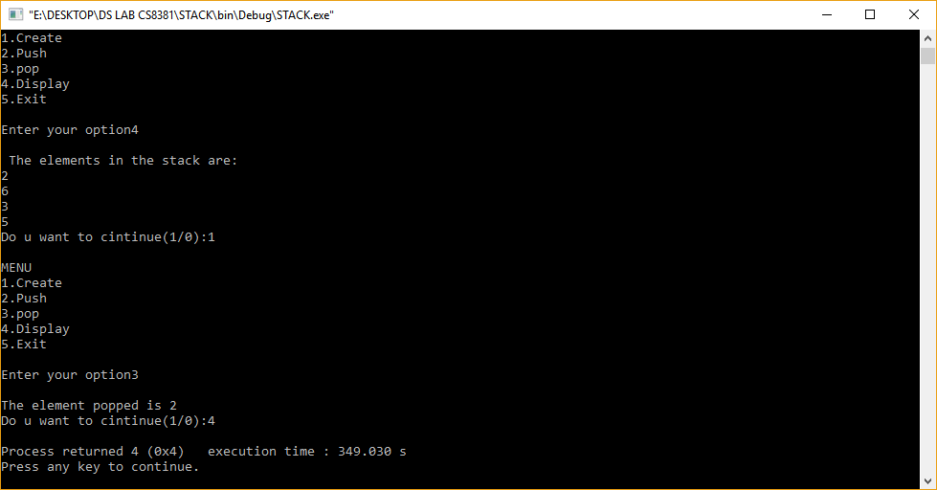

**RESULT:**

Thus a C program for Stack using ADT was implemented successfully**.**

DEPARTMENT OF COMPUTER SCIENCE AND ENGINEERING PEC

## EX. NO: 1B QUEUE ADT USING ARRAY

CS8381 DATA STRUCTURES LABORATORY

**AIM:**

To write a program for Queue using array implementation.

## DESCRIPTION:

A queue data structure can be implemented using one dimensional array. But, queue implemented using array can store only fixed number of data values. The implementation of queue data structure using array is very simple, just define a one dimensional array of specific size and insert or delete the values into that array by using FIFO (First In First Out) principle with the help of variables 'front' and 'rear'. Initially both 'front' and 'rear' are set to -1. Whenever, we want to insert a new value into the queue, increment 'rear' value by one and then insert at that position. Whenever we want to delete a value from the queue, then increment 'front' value by one and then display the value at 'front' position as deleted element. **ALGORITHM:**

1. Define a array which stores queue elements..
2. The operations on the queue are
   1. a)INSERT data into the queue
   2. b)DELETE data out of queue
3. INSERT DATA INTO queue
   1. Enter the data to be inserted into queue.
   2. If TOP is NULL
      1. The input data is the first node in queue.
      2. The link of the node is NULL.
      3. TOP points to that node.
   3. If TOP is NOT NULL
      1. The link of TOP points to the new node.
      2. TOP points to that node.
4. DELETE DATA FROM queue
   1. If TOP is NULL
      1. the queue is empty
   2. If TOP is NOT NULL
      1. The link of TOP is the current TOP.
      2. The pervious TOP is popped from queue.
5. The queue represented by linked list is traversed to display its content.

DEPARTMENT OF COMPUTER SCIENCE AND ENGINEERING PEC

**PROGRAM**

CS8381 DATA STRUCTURES LABORATORY

# #include<stdio.h> #include<conio.h> #include<stdlib.h> #define SIZE 5

**int front = - 1; int rear = - 1; int q[SIZE]; void insert( ); void del( ); void display( ); void main( )**

# {

**int choice; do**

# {

**printf("\t Menu"); printf("\n 1. Insert");**

# printf("\n 2. Delete"); printf("\n 3. Display ");

**printf("\n 4. Exit"); printf("\n Enter Your Choice:"); scanf("%d", &choice); switch(choice)**

# {

**case 1:**

# insert( ); display( ); break; case 2:

**del( ); display( ); break; case 3:display( );**

DEPARTMENT OF COMPUTER SCIENCE AND ENGINEERING PEC

# break; case 4:

**printf("End of Program. !!!!");**

# exit(0);

**}}while(choice != 4);} void insert( )**

# {

**int no;**

# printf("\n Enter No.:");

**scanf("%d", &no);**

# if(rear < SIZE - 1)

**{**

# q[++rear]=no; if(front == -1)

**front=0;// front=front+1;**

# }

**else**

# {

**printf("\n Queue overflow");**

# }}

**void del( )**

# {

**if(front == - 1)**

# {

**printf("\n Queue Underflow"); return;**

# }

**else**

DEPARTMENT OF COMPUTER SCIENCE AND ENGINEERING PEC

DEPARTMENT OF COMPUTER SCIENCE AND ENGINEERING PEC

# {

**printf("\n Deleted Item:-->%d\n", q[front]);**

# }

**if(front == rear)**

# {

**front = - 1; rear = - 1;**

# }

**else**

# {front = front + 1;

**}}**

# void display( )

**{**

# int i;

**if( front == - 1)**

# {

**printf("\nQueue is empty. ");**

# return;

**}**

# for(i = front; i<=rear; i++) printf("\t%d",q[i]);}

**OUTPUT**

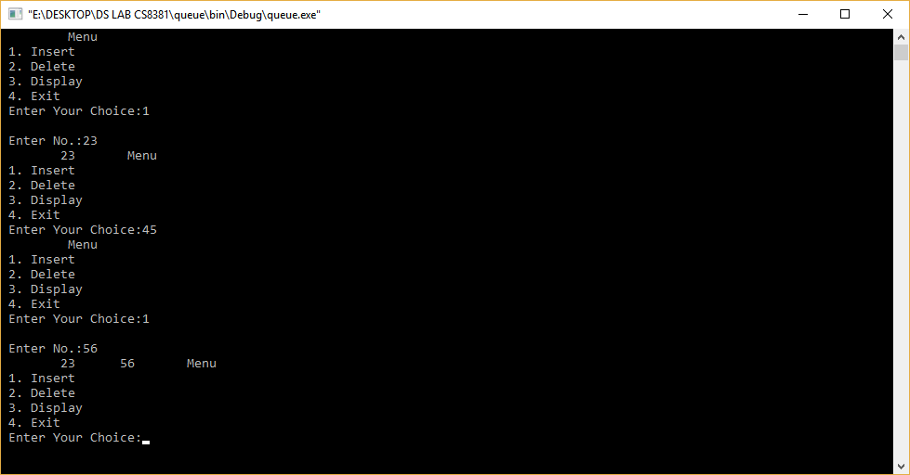

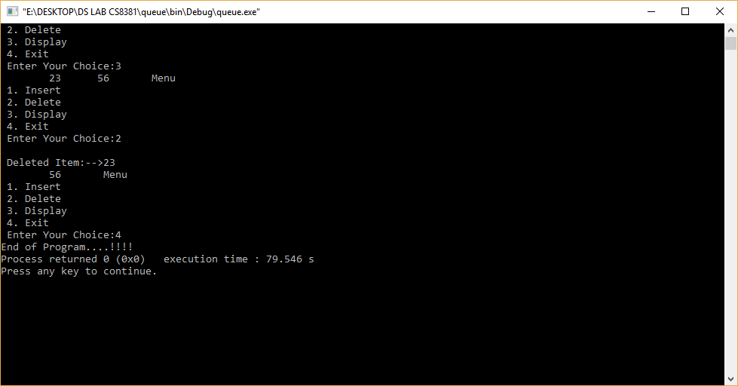

**RESULT:**

Thus a C program for Queue using ADT was implemented successfully

DEPARTMENT OF COMPUTER SCIENCE AND ENGINEERING PEC

## EX.NO:2 ARRAY IMPLEMENTATION OF LIST ADT

**AIM:**

.

To write a program for List using array implementation.

## DESCRIPTION:

A linked list is a sequence of data structures, which are connected together via links. Linked List is a sequence of links which contains items. Each link contains a connection to another link. Linked list is the second most-used data structure after array.

A linked list is a sequence of data structures, which are connected together via links. Linked List is a sequence of links which contains items. Each link contains a connection to another link. Linked list is the second most-used data structure after array.

Following are the important terms to understand the concept of Linked List.

* Link − each link of a linked list can store a data called an element.
* Next − each link of a linked list contains a link to the next link called Next.
* Linked List − A Linked List contains the connection link to the first link called First.

## ALGORITHM:

Step1: Create nodes first, last; next, prev and cur then set the value as NULL. Step 2: Read the list operation type.

Step 3: If operation type is create then process the following steps.

1. Allocate memory for node cur.
2. Read data in cur's data area.
3. Assign cur node as NULL.
4. Assign first=last=cur.

Step 4: If operation type is Insert then process the following steps.

1. Allocate memory for node cur.
2. Read data in cur's data area.
3. Read the position the Data to be insert.
4. Availability of the position is true then assing cur's node as first and first=cur.
5. If availability of position is false then do following steps.
   1. Assign next as cur and count as zero.
   2. Repeat the following steps until count less than postion. 1 .Assign prev as next

2. Next as prev of node. 3. Add count by one.

DEPARTMENT OF COMPUTER SCIENCE AND ENGINEERING PEC

1. If prev as NULL then display the message INVALID POSITION.
2. If prev not qual to NULL then do the following steps.
   1. Assign cur's node as prev's node.
   2. Assign prev's node as cur.

Step5: If operation type is delete then do the following steps.

1. Read the position .
2. Check list is Empty .If it is true display the message List empty.
3. If position is first.
   1. Assign cur as first.
   2. Assign First as first of node.
   3. Reallocate the cur from memory.
   4. If position is last.
      1. Move the current node to prev.
      2. cur's node as Null.
      3. Reallocate the Last from memory.
      4. Assign last as cur.
      5. If position is enter Mediate.
         1. Move the cur to required postion.
         2. Move the Previous to cur's previous position
         3. Move the Next to cur's Next position.
         4. Now Assign previous of node as next.
         5. Reallocate the cur from memory. step 6: If operation is traverse.
4. Assign current as first.
5. Repeat the following steps untill cur becomes NULL.

## PROGRAM:

#include<stdio.h> #include<conio.h> #define MAX 10 void create(); void insert(); void deletion(); void search(); void display();

DEPARTMENT OF COMPUTER SCIENCE AND ENGINEERING PEC

int a,b[20], n, p, e, f, i, pos; void main()

{

clrscr(); int ch; char g='y'; do

{

printf("\n main Menu");

printf("\n 1.Create \n 2.Delete \n 3.Search \n 4.Insert \n 5.Display\n 6.Exit

\n");

printf("\n Enter your Choice"); scanf("%d", &ch);

switch(ch)

{

case 1:

create(); break; case 2:

deletion(); break;

case 3:

search(); break; case 4:

insert(); break; case 5:

display(); break; case 6:

exit(); break; default:

printf("\n Enter the correct choice:");

DEPARTMENT OF COMPUTER SCIENCE AND ENGINEERING PEC

}

CS8381 DATA STRUCTURES LABORATORY

printf("\n Do u want to continue:::"); scanf("\n%c", &g);

}

while(g=='y'||g=='Y'); getch();

}

void create()

{

printf("\n Enter the number of nodes"); scanf("%d", &n);

for(i=0;i<n;i++)

{

printf("\n Enter the Element:",i+1); scanf("%d", &b[i]);

}

}

void deletion()

{

printf("\n Enter the position u want to delete::"); scanf("%d", &pos);

if(pos>=n)

{

printf("\n Invalid Location::");

}

else

{

for(i=pos+1;i<n;i++)

{

b[i-1]=b[i];

}

n--;

}

printf("\n The Elements after deletion");

DEPARTMENT OF COMPUTER SCIENCE AND ENGINEERING PEC

for(i=0;i<n;i++)

{

printf("\t%d", b[i]);

}

}

void search()

{

printf("\n Enter the Element to be searched:"); scanf("%d", &e);

for(i=0;i<n;i++)

{

if(b[i]==e)

{

printf("Value is in the %d Position", i);

}}}

void insert()

{

printf("\n Enter the position u need to insert::"); scanf("%d", &pos);

if(pos>=n)

{

printf("\n invalid Location::");

} else

{

for(i=MAX-1;i>=pos-1;i--)

{

b[i+1]=b[i];

}

printf("\n Enter the element to insert::\n"); scanf("%d",&p);

b[pos]=p; n++;

}

printf("\n The list after insertion::\n");

DEPARTMENT OF COMPUTER SCIENCE AND ENGINEERING PEC

display();} void display(){

printf("\n The Elements of The list ADT are:"); for(i=0;i<n;i++)

{

printf("\n\n%d", b[i]);

}}

**OUTPUT**

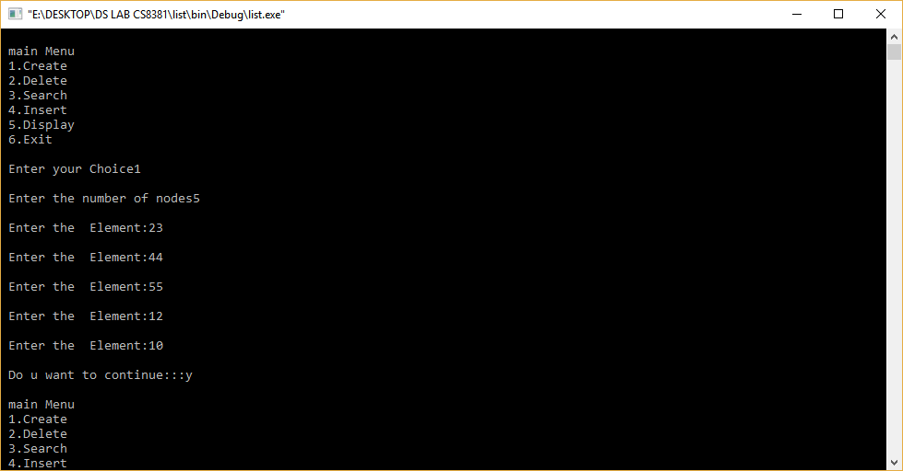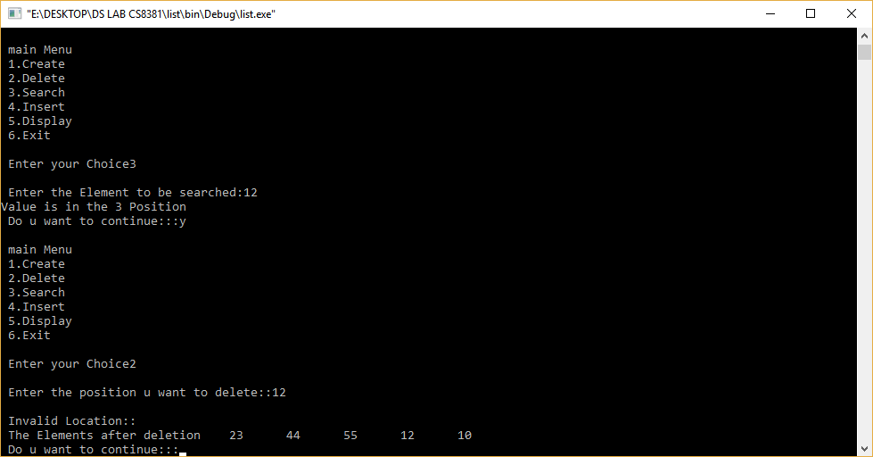

## RESULT:

Thus the C program for array implementation of List ADT was created, executed and output was verified successfully

DEPARTMENT OF COMPUTER SCIENCE AND ENGINEERING PEC

## EX. NO: 3A STACK ADT USING LINKED LIST

**AIM:**

To write a C program for stack ADT using linked list implementation.

## DESCRIPTION:

The major problem with the stack implemented using array is, it works only for fixed number of data values. That means the amount of data must be specified at the beginning of the implementation itself. Stack implemented using array is not suitable, when we don't know the size of data which we are going to use. A stack data structure can be implemented by using linked list data structure. The stack implemented using linked list can work for unlimited number of values. That means, stack implemented using linked list works for variable size of data. So, there is no need to fix the size at the beginning of the implementation. The Stack implemented using linked list can organize as many data values as we want.

In linked list implementation of a stack, every new element is inserted as 'top' element. That means every newly inserted element is pointed by 'top'. Whenever we want to remove an element from the stack, simply remove the node which is pointed by 'top' by moving 'top' to its next node in the list. The next field of the first element must be always NULL.

## ALGORITHM:

1. Define a struct for each node in the stack. Each node in the stack contains data and link to the next node. TOP pointer points to last node inserted in the stack.
2. The operations on the stack are
   1. PUSH data into the stack
   2. POP data out of stack
3. PUSH DATA INTO STACK
   1. Enter the data to be inserted into stack.
   2. If TOP is NULL
      1. The input data is the first node in stack.
      2. The link of the node is NULL.
      3. TOP points to that node.
   3. If TOP is NOT NULL
      1. The link of TOP points to the new node.
      2. TOP points to that node.
4. POP DATA FROM STACK

DEPARTMENT OF COMPUTER SCIENCE AND ENGINEERING PEC

* 1. 4a.If TOP is NULL
     1. the stack is empty
  2. 4b.If TOP is NOT NULL
     1. The link of TOP is the current TOP.
     2. The pervious TOP is popped from stack.

1. The stack represented by linked list is traversed to display its content.

## PROGRAM:

#include<stdio.h> #include<conio.h> #include<alloc.h> struct node

{

int data;

struct node *next;

}*top,*new1,*first;

void main()

{

int wish,opt;

void create(),push(),pop(),view(); do

{

clrscr();

printf("Stack using linked list menu"); printf("\n1.Create\n2.Push\n3.Pop\n4.View\n5.Exit\n"); printf("\nEnter your option(1,2,3,4,5):"); scanf("%d",&wish);

switch(wish)

{

case 1: create(); break; case 2: push(); break; case 3: pop(); break;

DEPARTMENT OF COMPUTER SCIENCE AND ENGINEERING PEC

case 4: view(); break; case 5: exit(0);

}

printf("\nDo you wnat to continue(0/1):"); scanf("%d",&opt);

}while(opt==1);

}

void create()

{

int ch;

top=(struct node*)malloc(sizeof(struct node)); top->next=NULL;

do

{

clrscr();

printf("Enter the data:\n"); scanf("%d",&top->data);

printf("Do you want to insert another(1/0)\n"); scanf("%d",&ch);

if(ch==1)

{

}

else

new1=(struct node*)malloc(sizeof(struct node)); new1->next=top;

top=new1; first=top;

break;

}while(ch==1);

}

void push()

{

top=first;

new1=(struct node*)malloc(sizeof(struct node)); printf("Enter the element to be pushed:");

DEPARTMENT OF COMPUTER SCIENCE AND ENGINEERING PEC

scanf("%d",&new1->data); new1->next=top; top=new1;

CS8381 DATA STRUCTURES LABORATORY

first=top;

}

void pop()

{

clrscr(); top=first; if(top==NULL)

printf("\n Stack is empty"); else

{

}}

void view()

{

printf("\nThe element popped out from stack is %d",top->data); top=top->next;

first=top;

DEPARTMENT OF COMPUTER SCIENCE AND ENGINEERING PEC

printf("\nStack contents\n"); while(top->next!=NULL)

{printf("%d->",top->data); top=top->next;}

printf("%d\n",top->data);

getch();}

**OUTPUT**

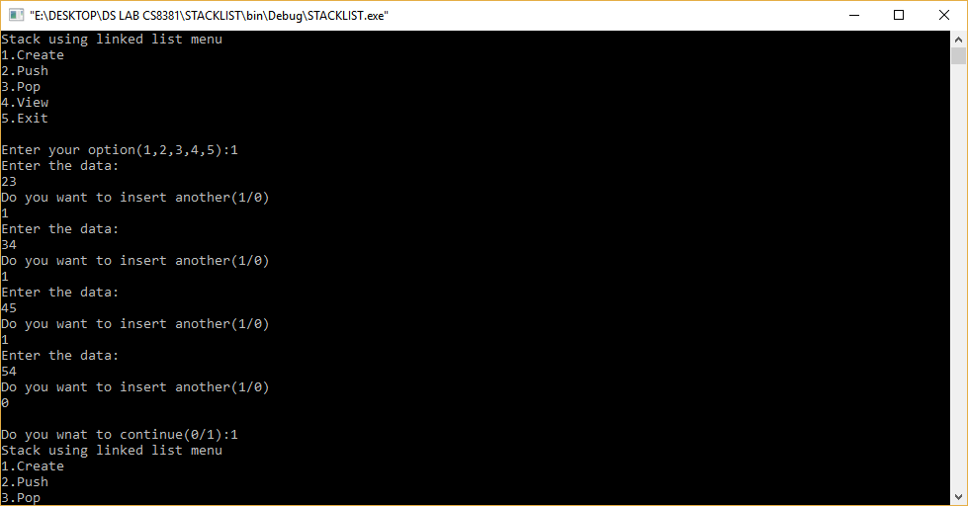

CS8381 DATA STRUCTURES LABORATORY

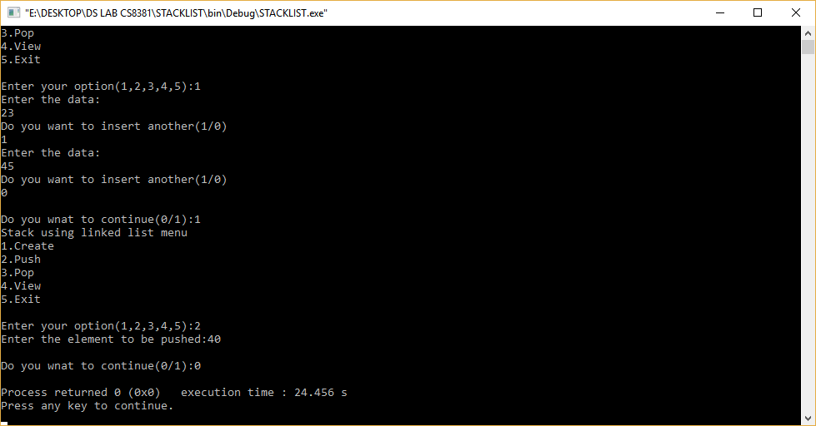

## RESULT:

Thus the C program for array implementation of Stack ADT was created, executed and output was verified successfully

DEPARTMENT OF COMPUTER SCIENCE AND ENGINEERING PEC

## EX. NO :3B QUEUE ADT USING LINKED LIST

CS8381 DATA STRUCTURES LABORATORY

**AIM:**

To write a C program for Queue using Linked implementation.

## DESCRIPTION:

Queue is an abstract data structure, somewhat similar to Stacks. Unlike stacks, a queue is open at both its ends. One end is always used to insert data(enqueue) and the other is used to remove data(dequeue). Queue follows First-In-First-Out methodology, i.e., the data item stored first will be accessed first.

Queue is an abstract data structure, somewhat similar to Stacks. Unlike stacks, a queue is open at both its ends. One end is always used to insert data (enqueue) and the other is used to remove data (dequeue). Queue follows First-In-First-Out methodology, i.e., the data item stored first will be accessed first.

Queue operations may involve initializing or defining the queue, utilizing it, and then completely erasing it from the memory. Here we shall try to understand the basic operations associated with queues.

* enqueue () − add (store) an item to the queue.
* dequeue () − remove (access) an item from the queue.

Few more functions are required to make the above-mentioned queue operation efficient. These are

* peek() − Gets the element at the front of the queue without removing it.
* isfull() − Checks if the queue is full.
* isempty() − Checks if the queue is empty.

## ALGORITHM:

1. Define a struct for each node in the queue. Each node in the queue

contains data and link to the next node. Front and rear pointer points to first and last node inserted in the queue.

1. The operations on the queue are
   1. INSERT data into the queue
   2. DELETE data out of queue
2. INSERT DATA INTO queue
   1. Enter the data to be inserted into queue.

DEPARTMENT OF COMPUTER SCIENCE AND ENGINEERING PEC

* 1. If TOP is NULL
     1. The input data is the first node in queue. ii. The link of the node is NULL.

1. TOP points to that node. c. If TOP is NOT NULL
   1. The link of TOP points to the new node. ii. TOP points to that node.
2. DELETE DATA FROM queue a. If TOP is NULL

i. the queue is empty b. If TOP is NOT NULL

1. The link of TOP is the current TOP.
2. The pervious TOP is popped from queue.
3. The queue represented by linked list is traversed to display its content.

## PROGRAM:

#include<stdio.h> #include<conio.h> struct node

{

int info;

struct node *link;

}*front = NULL, *rear = NULL;

void insert(); void delet(); void display(); int item;

void main()

{

int ch; do

{

printf("\n\n1.\tEnqueue\n2.\tDequeue\n3.\tDisplay\n4.\tExit\n");

DEPARTMENT OF COMPUTER SCIENCE AND ENGINEERING PEC

printf("\nEnter your choice: "); scanf("%d", &ch);

switch(ch)

{

case 1:

insert(); break; case 2:

delet(); break; case 3:

display(); break; case 4:

exit(0); default:

printf("\n\nInvalid choice. Please try again...\n");

}

} while(1);

getch();

}

void insert()

{

printf("\n\nEnter ITEM: "); scanf("%d", &item);

if(rear == NULL)

{

rear = (struct node *)malloc(sizeof(struct node)); rear->info = item;

rear->link = NULL; front = rear;

}

else{

DEPARTMENT OF COMPUTER SCIENCE AND ENGINEERING PEC

rear->link = (struct node *)malloc(sizeof(struct node)); rear = rear->link;

rear->info = item; rear->link = NULL;

}}

void delet(){ struct node *ptr; if(front == NULL)

printf("\n\nQueue is empty.\n"); else{

ptr = front;

item = front->info; front = front->link; free(ptr);

printf("\nItem deleted: %d\n", item); if(front == NULL)

rear = NULL;

}}

void display()

{

struct node *ptr = front; if(rear == NULL) printf("\n\nQueue is empty.\n"); else

{

printf("\n\n"); while(ptr != NULL)

{

printf("%d\t",ptr->info); ptr = ptr->link;

}}}

DEPARTMENT OF COMPUTER SCIENCE AND ENGINEERING PEC

**OUTPUT**

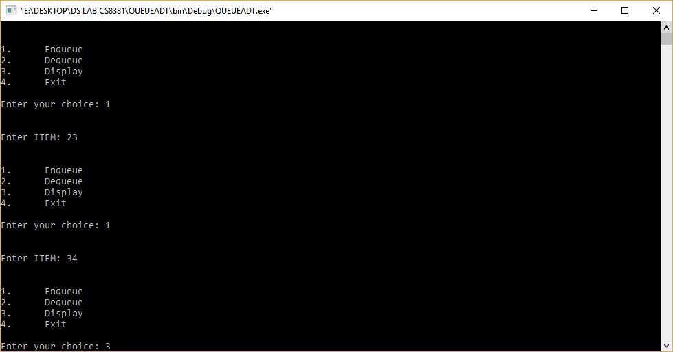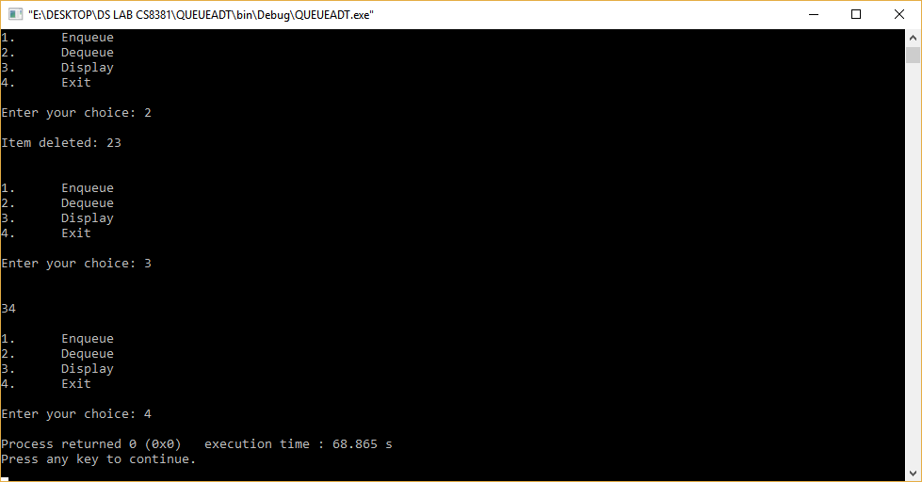

## RESULT:

Thus the C program for array implementation of Queue ADT was created, executed and output was verified successfully

DEPARTMENT OF COMPUTER SCIENCE AND ENGINEERING PEC

# EXNO:4A REPRESENT A POLYNOMIAL AS A LINKED LIST

CS8381 DATA STRUCTURES LABORATORY

## AIM:

To write program in C to convert given infix expression in to postfix notation

**DESCRIPTION:**

A polynomial is homogeneous ordered list of pairs <exponent, coefficient>, where each coefficient is unique.

Example: 3x2+5x+7

Linked list representation

The main fields of polynomial are coefficient and exponent, in linked list it will have one more filed called „link‟ field to point to next term in the polynomial. If there are

„n‟ terms in the polynomial then „'n‟ such nodes have to be created.

**ALGORITHM:**

1: Get the two polynomials. First polynomial is P1 and second polynomial is P2

2: For addition of two polynomials if exponents of both the polynomials are same then we ad the coefficients. For storing the result we will create the third linked lists say P3.

3: If Exponent of P2 is greater than exponent of P1 then keep the P3 as P2. 4: If Exponent of P2 is greater than exponent of P1 then keep the P3 as P1

5: If Exponent of P2 is equal to the exponent of P1 then add the coefficient of P1 and coefficient of P2 as coefficient of P3.

6: Continue the above step from 3 to 5 until end o the two polynomials.

7: If any of the polynomial is ended keep P3 as the remaining polynomial. 8: Stop the execution.

## PROGRAM:

#include<stdio.h> #include<conio.h>

main()

{

int a[10], b[10], c[10],m,n,k,k1,i,j,x; clrscr();

printf("\n\tPolynomial Addition\n"); printf("\t===================\n");

printf("\n\tEnter the no. of terms of the polynomial:"); scanf("%d", &m);

printf("\n\tEnter the degrees and coefficients:"); for (i=0;i<2*m;i++)

scanf("%d", &a[i]);

DEPARTMENT OF COMPUTER SCIENCE AND ENGINEERING PEC

printf("\n\tFirst polynomial is:"); k1=0;

CS8381 DATA STRUCTURES LABORATORY

if(a[k1+1]==1)

printf("x^%d", a[k1]); else

printf("%dx^%d", a[k1+1],a[k1]); k1+=2;

while (k1<i)

{

printf("+%dx^%d", a[k1+1],a[k1]); k1+=2;

}

printf("\n\n\n\tEnter the no. of terms of 2nd polynomial:"); scanf("%d", &n);

printf("\n\tEnter the degrees and co-efficients:"); for(j=0;j<2*n;j++)

scanf("%d", &b[j]); printf("\n\tSecond polynomial is:"); k1=0;

if(b[k1+1]==1)

printf("x^%d", b[k1]); else

printf("%dx^%d",b[k1+1],b[k1]); k1+=2;

while (k1<2*n)

{

printf("+%dx^%d", b[k1+1],b[k1]); k1+=2;

} i=0; j=0; k=0;

while (m>0 && n>0)

{

if (a[i]==b[j])

{ c[k+1]=a[i+1]+b[j+1];

c[k]=a[i]; m--;

n--; i+=2; j+=2;

}

else if (a[i]>b[j])

{ c[k+1]=a[i+1];

c[k]=a[i]; m--;

i+=2;

}

else

{ c[k+1]=b[j+1];

c[k]=b[j]; n--;

j+=2;

} k+=2;

}

while (m>0)

{ c[k+1]=a[i+1];

c[k]=a[i];

DEPARTMENT OF COMPUTER SCIENCE AND ENGINEERING PEC

k+=2; i+=2; m--;

}

while (n>0)

{ c[k+1]=b[j+1];

c[k]=b[j]; k+=2; j+=2;

n--;

}

printf("\n\n\n\n\tSum of the two polynomials is:"); k1=0;

if (c[k1+1]==1)

printf("x^%d", c[k1]); else

printf("%dx^%d", c[k1+1],c[k1]); k1+=2;

while (k1<k)

{

if (c[k1+1]==1)

printf("+x^%d", c[k1]); else

printf("+%dx^%d", c[k1+1], c[k1]); k1+=2;

}

getch(); return 0;

}

OUTPUT

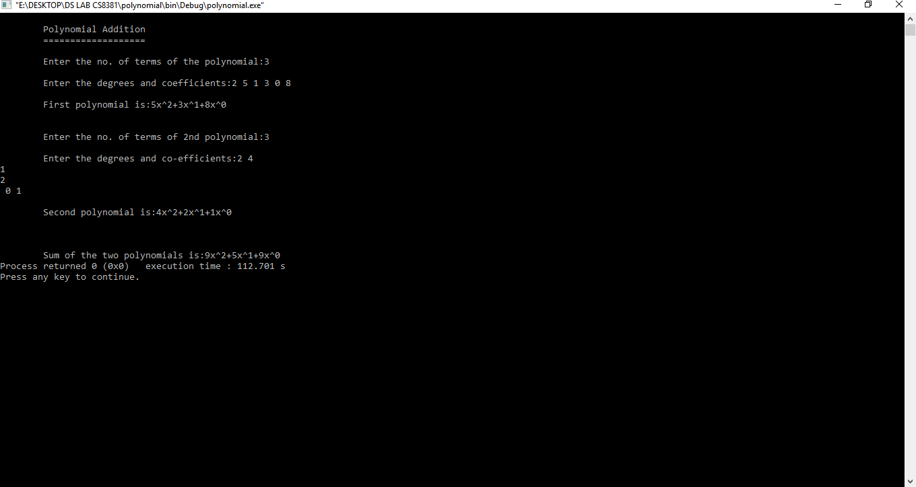

## RESULT:

Thus the program in C to convert given infix expression in to postfix notation

DEPARTMENT OF COMPUTER SCIENCE AND ENGINEERING PEC

# EX.NO:4B CONVERSION OF INFIX EXPRESSION TO POSTFIX NOTATION AIM:

To write program in C to convert given infix expression to postfix notation

**ALGORITHM:**

1: Get an infix expression.

2: Scan the expression from left to right. 3: If any operands come display it.

4: If the incoming symbol in a operator and has more priority then the symbol into the stack. 5: If the incoming operator has less priority than the stack symbol then copy the symbol at the

top of the stack and then print until the condition becomes false and push the following operator on the stack.

6: If the symbol is ‘)’ then copy operators from top of the stack. Deletion opening parenthesis is from top of the stack.

7: Stop the process.

**DESCRIPTION:**

**Infix expression:**The expression of the form a op b. When an operator is in-between every pair of operands.

**Postfix expression:**The expression of the form a b op. When an operator is followed for every pair of operands.

**PROGRAM:**

#include<stdio.h> char stack[20]; int top = -1; void push(char x)

{

stack[++top] = x;

}

char pop()

{

if(top == -1)

return -1; else

return stack[top--];

}

int priority(char x)

{

if(x == '(')

return 0;

if(x == '+' || x == '-') return 1;

if(x == '*' || x == '/')

DEPARTMENT OF COMPUTER SCIENCE AND ENGINEERING PEC

return 2;

}

main()

{

char exp[20]; char *e, x;

printf("Enter the expression :: "); scanf("%s",exp);

e = exp;

while(*e != '\0')

{

if(isalnum(*e)) printf("%c",*e);

else if(*e == '(') push(*e);

else if(*e == ')')

{

while((x = pop()) != '(') printf("%c", x);

}

else

{

while(priority(stack[top]) >= priority(*e)) printf("%c",pop());

push(*e);

}

e++;

}

while(top != -1)

{

printf("%c",pop());

}

}

**OUTPUT**

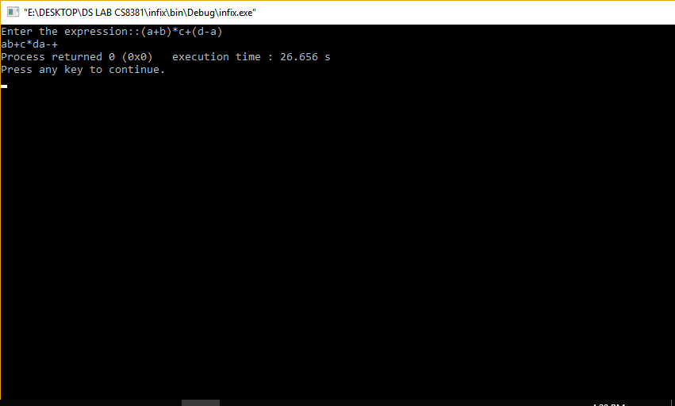

**RESULT:**

Thus the program in C to convert given infix expression to postfix notation

DEPARTMENT OF COMPUTER SCIENCE AND ENGINEERING PEC

EXNO:5 IMPLEMENTATION BINARY TREE AND OPERATIONS OF BINARY TREES

CS8381 DATA STRUCTURES LABORATORY

# AIM:

To write a C program Implementation Binary Tree And Operations Of Binary Trees

**DESCRIPTION:**

A binary tree is a tree data structure where each node has up to two child nodes, creating the branches of the tree. The two children are usually called the left and right nodes. Parent nodes are nodes with children, while child nodes may include references to their parents.

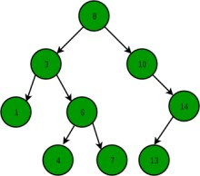

**ALGORITHM**

1. Start from root.
2. Compare the inserting element with root, if less than root, then recurse for left, else recurse for right.
3. If element to search is found anywhere, return true, else return false

**PROGRAM**

#include<stdio.h> #include<stdlib.h>

struct tree {

int data;

struct tree *left; struct tree *right;

} *root = NULL, *node = NULL, *temp = NULL;

struct tree* insert(int key,struct tree *leaf) { if(leaf == 0) {

struct tree *temp;

temp = (struct tree *)malloc(sizeof(struct tree)); temp->data = key;

temp->left = 0;

temp->right = 0; printf("Data inserted!\n"); return temp;

}

else {

if(key < leaf->data)

leaf->left = insert(key,leaf->left);

else

leaf->right = insert(key,leaf->right);

}

return leaf;

}

struct tree* search(int key,struct tree *leaf) { if(leaf != NULL) {

if(key == leaf->data) { printf("Data found!\n"); return leaf;

}

else {

if(key < leaf->data)

return search(key,leaf->left);

else

DEPARTMENT OF CSE Priyadarshini Engineering College Page 36

return search(key,leaf->right); Y

CS8381 DATA STRUCTURES LABORATOR

}

}

else {

printf("Data not found!\n");return NULL;

}}

struct tree* minvalue(struct tree *node) { if(node == NULL)

return NULL;

if(node->left)

return minvalue(node->left);

else

return node;

}

/* Function for find maximum value from the Tree */ struct tree* maxvalue(struct tree *node) {

if(node == NULL)

return NULL;

if(node->right)

return maxvalue(node->right);

else

return node;

}

void preorder(struct tree *leaf) { if(leaf == NULL)

return; printf("%d\n",leaf->data); preorder(leaf->left); preorder(leaf->right);

}

void inorder(struct tree *leaf) { if(leaf == NULL)

return; preorder(leaf->left); printf("%d\n",leaf->data); preorder(leaf->right);

}

void postorder(struct tree *leaf) { if(leaf == NULL)

return; preorder(leaf->left); preorder(leaf->right); printf("%d\n",leaf->data);

}

struct tree* delete(struct tree *leaf, int key) { if(leaf == NULL)

printf("Element Not Found!\n"); else if(key < leaf->data)

leaf->left = delete(leaf->left, key); else if(key > leaf->data)

leaf->right = delete(leaf->right, key);

else {

if(leaf->right && leaf->left) {

temp = minvalue(leaf->right); leaf->data = temp->data;

DEPARTMENT OF CSE Priyadarshini Engineering College Page 37

leaf->right = delete(leaf->right,temp->data);

}

else {

}

}

}

temp = leaf;

if(leaf->left == NULL) leaf = leaf->right;

else if(leaf->right == NULL) leaf = leaf->left;

free(temp);

printf("Data delete successfully!\n");

int main() {

int key, choice; while(choice != 7) {

printf("1. Insert\n2. Search\n3. Delete\n4. Display\n5. Min Value\n6.

Max Value\n7. Exit\n");

printf("Enter your choice:\n"); scanf("%d", &choice); switch(choice) {

case 1:

printf("\nEnter the value to insert:\n"); scanf("%d", &key);

root = insert(key, root); break;

case 2:

printf("\nEnter the value to search:\n"); scanf("%d", &key);

search(key,root); break;

case 3:

printf("\nEnter the value to delete:\n"); scanf("%d", &key);

delete(root,key); break;

case 4:

printf("Preorder:\n"); preorder(root); printf("Inorder:\n"); inorder(root); printf("Postorder:\n"); postorder(root);

break; case 5:

if(minvalue(root) == NULL) printf("Tree is empty!\n");

>data);

else

printf("Minimum value is %d\n", minvalue(root)-

break; case 6:

if(maxvalue(root) == NULL) printf("Tree is empty!\n");

>data);

else

printf("Maximum value is %d\n", maxvalue(root)-

break; case 7:

CS8381 DATA STRUCTURES LABORATORY

printf("Bye Bye!\n"); exit(0);

break; default:

printf("Invalid choice!\n");

}

}

return 0;

DEPARTMENT OF CSE Priyadarshini Engineering College Page 38

}

CS8381 DATA STRUCTURES LABORATORY

**OUTPUT**

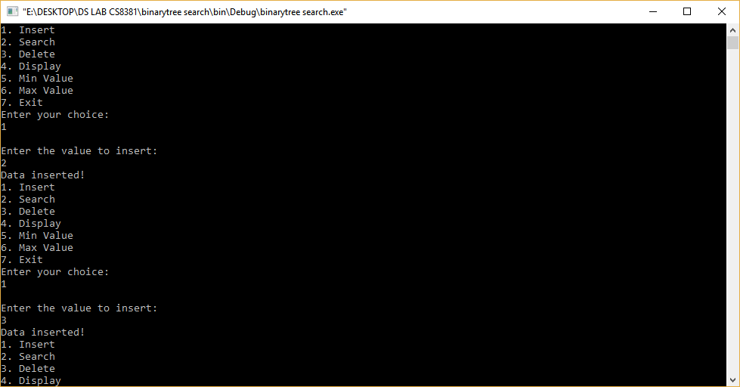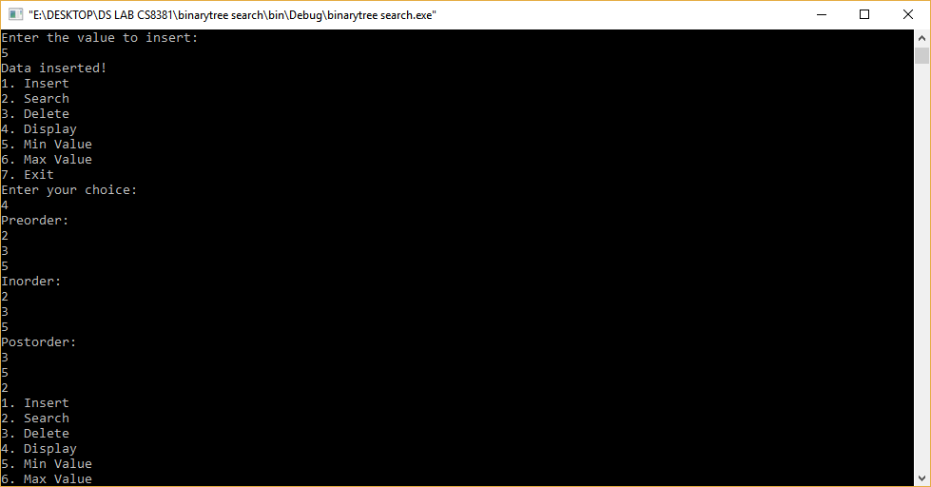

**Result:**

Thus the program in C is implementated Binary Tree and Operations of Binary Trees.

DEPARTMENT OF CSE Priyadarshini Engineering College Page 39

## EX. NO: 6 IMPLEMENTATION OF BINARY SEARCH TREE

**AIM:**

To write a C program to implementation of binary search tree.

## DESCRIPTION:

A Binary Search Tree (BST) is a tree in which all the nodes follow the below- mentioned properties

The left sub-tree of a node has a key less than or equal to its parent node's key. The right sub-tree of a node has a key greater than to its parent node's key.

Thus, BST divides all its sub-trees into two segments; the left sub-tree and the right sub-tree and can be defined as

left_subtree (keys) ≤ node (key) ≤ right_subtree (keys) Representation

BST is a collection of nodes arranged in a way where they maintain BST properties. Each node has a key and an associated value. While searching, the desired key is compared to the keys in BST and if found, the associated value is retrieved.

Following is a pictorial representation of BST Basic Operations

Following are the basic operations of a tree

* Search − Searches an element in a tree.
* Insert − Inserts an element in a tree.
* Pre-order Traversal − Traverses a tree in a pre-order manner.
* In-order Traversal − Traverses a tree in an in-order manner.
* Post-order Traversal − Traverses a tree in a post-order manner.

## ALGORITHM:

* 1. Declare function create (), search (), delete (), Display ().
  2. Create a structure for a tree contains left pointer and right pointer.
  3. Insert an element is by checking the top node and the leaf node and the operation will be performed.
  4. Deleting an element contains searching the tree and deleting the item.
  5. Display the Tree elements.

DEPARTMENT OF CSE Priyadarshini Engineering College Page 40

## PROGRAM:

#include<stdio.h> #include<conio.h> #include<process.h> #include<alloc.h>

struct tree

{

int data;

struct tree *lchild; struct tree *rchild;

}*t,*temp;

int element;

void inorder(struct tree *); void preorder(struct tree *); void postorder(struct tree *);

struct tree * create(struct tree *, int); struct tree * find(struct tree *, int); struct tree * insert(struct tree *, int); struct tree * del(struct tree *, int); struct tree * findmin(struct tree *); struct tree * findmax(struct tree *); void main()

{

int ch;

do

{

printf("\n\t\t\tBINARY SEARCH TREE"); printf("\n\t\t\t****** ****** ****"); printf("\nMain Menu\n");

printf("\n1.Create\n2.Insert\n3.Delete\n4.Find\n5.FindMin\n6.FindMax")

;

printf("\n7.Inorder\n8.Preorder\n9.Postorder\n10.Exit\n"); printf("\nEnter ur choice :");

scanf("%d",&ch); switch(ch)

{

case 1:

printf("\nEnter the data:"); scanf("%d",&element); t=create(t,element); inorder(t);

DEPARTMENT OF CSE Priyadarshini Engineering College Page 41

break; case 2:

printf("\nEnter the data:"); scanf("%d",&element); t=insert(t,element); inorder(t);

break; case 3:

printf("\nEnter the data:"); scanf("%d",&element); t=del(t,element); inorder(t);

break; case 4:

printf("\nEnter the data:"); scanf("%d",&element); temp=find(t,element); if(temp->data==element)

printf("\nElement %d is at %d",element,temp);

else

printf("\nElement is not found");

break; case 5:

temp=findmin(t);

printf("\nMax element=%d",temp->data); break;

case 6:

temp=findmax(t);

printf("\nMax element=%d",temp->data); break;

case 7:

inorder(t); break;

case 8:

preorder(t); break;

case 9:

postorder(t); break;

case 10:

exit(0);

}

}while(ch<=10);

}

DEPARTMENT OF CSE Priyadarshini Engineering College Page 4

2

struct tree * create(struct tree *t, int element)

CS8381 DATA STRUCTURES LABORATORY

{

t=(struct tree *)malloc(sizeof(struct tree)); t->data=element;

t->lchild=NULL; t->rchild=NULL; return t;

}

struct tree * find(struct tree *t, int element)

{

if(t==NULL)

return NULL; if(element<t->data)

return(find(t->lchild,element));

else

if(element>t->data)

return(find(t->rchild,element));

else

}

return t;

struct tree *findmin(struct tree *t)

{

if(t==NULL)

return NULL;

else

if(t->lchild==NULL)

return t;

else

}

return(findmin(t->lchild));

struct tree *findmax(struct tree *t)

{

if(t!=NULL)

{

while(t->rchild!=NULL) t=t->rchild;

}

return t;

}

struct tree *insert(struct tree *t,int element)

{

if(t==NULL)

{

DEPARTMENT OF CSE Priyadarshini Engineering College Page

43

}

else

{

t=(struct tree *)malloc(sizeof(struct tree)); t->data=element;

t->lchild=NULL; t->rchild=NULL; return t;

CS8381 DATA STRUCTURES LABORATORY

if(element<t->data)

{

}

else

t->lchild=insert(t->lchild,element);

if(element>t->data)

{

}

else

t->rchild=insert(t->rchild,element);

if(element==t->data)

{

printf("element already present\n");

}

return t;

}

}

struct tree * del(struct tree *t, int element)

{

if(t==NULL)

printf("element not found\n");

else

if(element<t->data)

t->lchild=del(t->lchild,element);

else

if(element>t->data)

t->rchild=del(t->rchild,element);

else

if(t->lchild&&t->rchild)

{

}

else

DEPARTMENT OF CSE Priyadarshini Engineering College Page 44

temp=findmin(t->rchild); t->data=temp->data;

1. **>rchild=del(t->rchild,t->data);**

{

CS8381 DATA STRUCTURES LABORATORY

temp=t;

if(t->lchild==NULL)

t=t->rchild;

return t;

}

else

}

if(t->rchild==NULL)

t=t->lchild; free(temp);

void inorder(struct tree *t)

{

if(t==NULL)

return;

else

{

}

}

inorder(t->lchild); printf("\t%d",t->data); inorder(t->rchild);

void preorder(struct tree *t)

{

if(t==NULL)

return;

else

{

}

}

printf("\t%d",t->data); preorder(t->lchild); preorder(t->rchild);

void postorder(struct tree *t)

{

if(t==NULL)

return;

else

{

postorder(t->lchild); postorder(t->rchild); printf("\t%d",t->data);}}

DEPARTMENT OF CSE Priyadarshini Engineering College Page 45

DEPARTMENT OF CSE Priyadarshini Engineering College Page 46

**OUTPUT:**

CS8381 DATA STRUCTURES LABORATORY

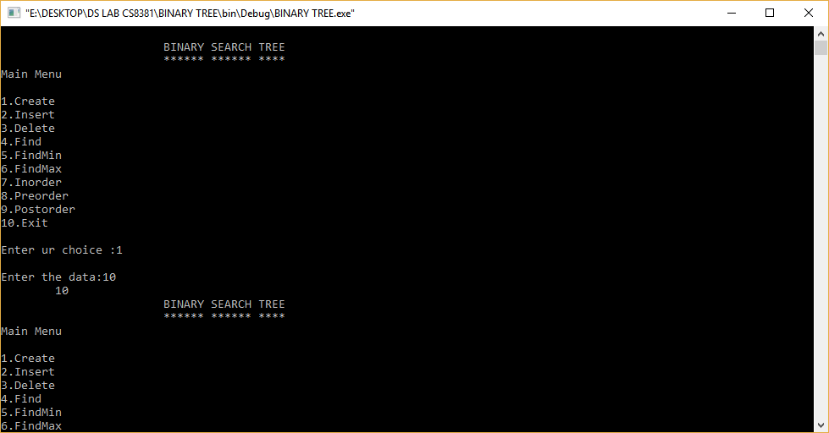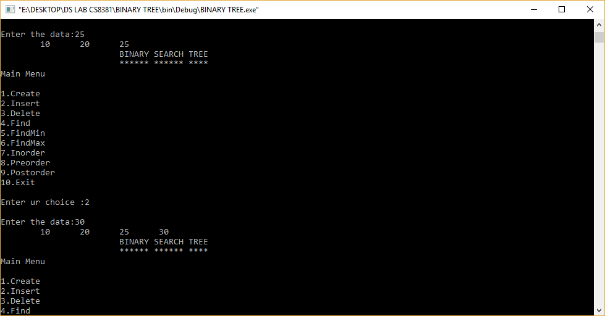

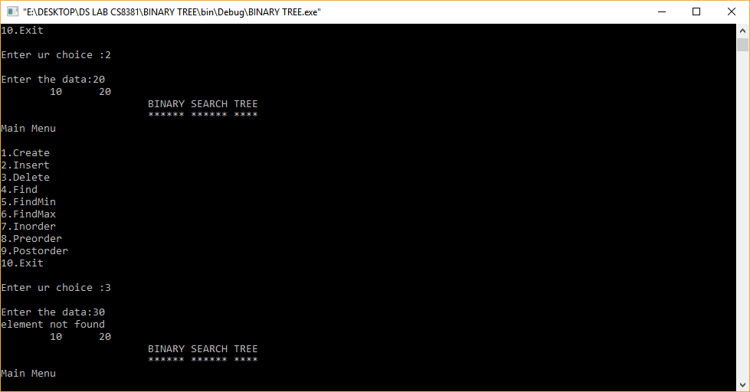

**RESULT:**

Thus the C program for binary search tree was created, executed and output was verified successfully.

DEPARTMENT OF CSE Priyadarshini Engineering College Page 47

# EX NO:7 IMPLEMENTATION OF AVL TREE AIM:-

To write a C program to implement insertion in AVL trees.

**ALGORITHM:-**

* 1. Initialize all variables and functions. 2.To insert and element read the value. 3.Check whether root is null

1. If yes make the new value as root.
2. Else check whether the value is equal to root value. 6.if yes, print “duplicate value”.

7.Otherwise insert the value at its proper position and balance the tree using rotations. 8.To display the tree values check whether the tree is null.

1. If yes, print “tree is empty”.
2. Else print all the values in the tree form and in order ofthe tree. 11.Repeat the steps 2 to 10 for more values.

12.End

**DESCRIPTION:**

**Adelson**, **Velski** & **Landis**, **AVL trees** are height balancing binary search tree. AVL tree checks the height of the left and the right sub-trees and assures that the difference is not more than 1. This difference is called the **Balance Factor**.

Here we see that the first tree is balanced and the next two trees are not balanced −

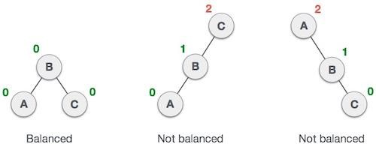

In the second tree, the left subtree of **C** has height 2 and the right subtree has height 0, so the difference is 2. In the third tree, the right subtree of **A** has height 2 and the left is missing, so it is 0, and the difference is 2 again. AVL tree permits difference (balance factor) to be only 1.

***BalanceFactor*** = height(left-sutree) − height(right-sutree)

If the difference in the height of left and right sub-trees is more than 1, the tree is balanced using some rotation techniques.

*AVL Rotations*

To balance itself, an AVL tree may perform the following four kinds of rotations −

* Left rotation

DEPARTMENT OF CSE Priyadarshini Engineering College Page 48

* Right rotation
* Left-Right rotation
* Right-Left rotation

The first two rotations are single rotations and the next two rotations are double rotations. To have an unbalanced tree, we at least need a tree of height 2. With this simple tree, let's understand them one by one.

Left Rotation

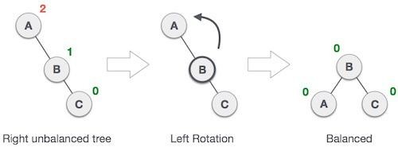If a tree becomes unbalanced, when a node is inserted into the right subtree of the right subtree, then we perform a single left rotation −

In our example, node **A** has become unbalanced as a node is inserted in the right subtree of A's right subtree. We perform the left rotation by making **A**the left-subtree of B.

*Right Rotation*

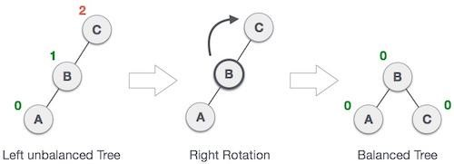AVL tree may become unbalanced, if a node is inserted in the left subtree of the left subtree. The tree then needs a right rotation.

As depicted, the unbalanced node becomes the right child of its left child by performing a right rotation.

Left-Right Rotation

Double rotations are slightly complex version of already explained versions of rotations. To understand them better, we should take note of each action performed while rotation. Let's first check how to perform Left-Right rotation. A left-right rotation is a combination of left rotation followed by right rotation.

DEPARTMENT OF CSE Priyadarshini Engineering College Page 49

DEPARTMENT OF CSE Priyadarshini Engineering College Page 50

|  |  |
| --- | --- |
| **State** | **Action** |
| Right Rotation | A node has been inserted into the right subtree of the left subtree. This makes **C** an unbalanced node. These scenarios cause AVL tree to perform left-right rotation. |
| Left Rotation | We first perform the left rotation on the left subtree of **C**. This makes **A**, the left subtree of **B**. |
| Left Rotation | Node **C** is still unbalanced, however now, it is because of the left-subtree of the left-subtree. |
| Right Rotation | We shall now right-rotate the tree, making **B** the new root node of this  subtree. **C** now becomes the right subtree of its own left subtree. |
| Balanced Avl Tree | The tree is now balanced. |

DEPARTMENT OF CSE Priyadarshini Engineering College Page 51

Right-Left Rotation

The second type of double rotation is Right-Left Rotation. It is a combination of right rotation followed by left rotation.

|  |  |
| --- | --- |
| **State** | **Action** |
| Left Subtree of Right Subtree | A node has been inserted into the left subtree of the right subtree. This makes **A**, an unbalanced node with balance factor 2. |
| Subtree Right Rotation | First, we perform the right rotation along **C** node, making **C** the right subtree of its own left  subtree **B**. Now, **B** becomes the right subtree of **A**. |
| Right Unbalanced Tree | Node **A** is still unbalanced because of the right subtree of its right subtree and requires a left rotation. |
| Left Rotation | A left rotation is performed by making **B** the new root node of the subtree. **A** becomes the left subtree of its right subtree **B**. |

The tree is now balanced.

CS8381 DATA STRUCTURES LABORATORY

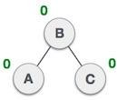

**PROGRAM**

#include<stdio.h> #include<malloc.h>

typedef enum { FALSE ,TRUE } bool; struct node

{

int info; int balance;

struct node *lchild; struct node *rchild;

};

struct node *insert (int , struct node *, int *); struct node* search(struct node *,int);

main()

{

bool ht_inc; int info ; int choice;

struct node *root = (struct node *)malloc(sizeof(struct node)); root = NULL;

while(1)

{

printf("1.Insert\n"); printf("2.Display\n"); printf("3.Quit\n"); printf("Enter your choice : ");

DEPARTMENT OF CSE Priyadarshini Engineering College Page 52

scanf("%d",&choice); switch(choice)

CS8381 DATA STRUCTURES LABORATORY

{

case 1:

printf("Enter the value to be inserted : "); scanf("%d", &info);

if( search(root,info) == NULL ) root = insert(info, root, &ht_inc); else

printf("Duplicate value ignored\n"); break;

case 2: if(root==NULL)

{

printf("Tree is empty\n"); continue;

}

printf("Tree is :\n"); display(root, 1); printf("\n\n");

printf("Inorder Traversal is: "); inorder(root);

printf("\n"); break;

case 3:

exit(1); default:

printf("Wrong choice\n");

}/*End of switch*/

}/*End of while*/

DEPARTMENT OF CSE Priyadarshini Engineering College Page 53

}/*End of main()*/

struct node* search(struct node *ptr,int info)

{

if(ptr!=NULL) if(info < ptr->info)

ptr=search(ptr->lchild,info); else if( info > ptr->info) ptr=search(ptr->rchild,info); return(ptr);

}/*End of search()*/

struct node *insert (int info, struct node *pptr, int *ht_inc)

{

struct node *aptr; struct node *bptr; if(pptr==NULL)

{

pptr = (struct node *) malloc(sizeof(struct node)); pptr->info = info;

pptr->lchild = NULL; pptr->rchild = NULL; pptr->balance = 0;

*ht_inc = TRUE; return (pptr);

}

if(info < pptr->info)

{

pptr->lchild = insert(info, pptr->lchild, ht_inc); if(*ht_inc==TRUE)

{

switch(pptr->balance)

{

DEPARTMENT OF CSE Priyadarshini Engineering College Page 54

case -1: /* Right heavy */ pptr->balance = 0;

*ht_inc = FALSE; break;

case 0: /* Balanced */ pptr->balance = 1; break;

case 1: /* Left heavy */ aptr = pptr->lchild; if(aptr->balance == 1)

{

printf("Left to Left Rotation\n"); pptr->lchild= aptr->rchild;

aptr->rchild = pptr; pptr->balance = 0; aptr->balance=0; pptr = aptr;

}

else

{

printf("Left to right rotation\n"); bptr = aptr->rchild;

aptr->rchild = bptr->lchild; bptr->lchild = aptr;

pptr->lchild = bptr->rchild; bptr->rchild = pptr;

if(bptr->balance == 1 ) pptr->balance = -1; else

pptr->balance = 0;

if(bptr->balance == -1)

DEPARTMENT OF CSE Priyadarshini Engineering College Page 55

aptr->balance = 1; else

aptr->balance = 0; bptr->balance=0; pptr=bptr;

}

*ht_inc = FALSE;

}/*End of switch */

}/*End of if */

}/*End of if*/ if(info > pptr->info)

{

pptr->rchild = insert(info, pptr->rchild, ht_inc); if(*ht_inc==TRUE)

{

switch(pptr->balance)

{

case 1: /* Left heavy */ pptr->balance = 0;

*ht_inc = FALSE; break;

case 0: /* Balanced */ pptr->balance = -1; break;

case -1: /* Right heavy */ aptr = pptr->rchild; if(aptr->balance == -1)

{

printf("Right to Right Rotation\n"); pptr->rchild= aptr->lchild;

aptr->lchild = pptr;

DEPARTMENT OF CSE Priyadarshini Engineering College Page 56

pptr->balance = 0; aptr->balance=0; pptr = aptr;

}

else

{

printf("Right to Left Rotation\n"); bptr = aptr->lchild;

aptr->lchild = bptr->rchild; bptr->rchild = aptr;

pptr->rchild = bptr->lchild; bptr->lchild = pptr;

if(bptr->balance == -1)

pptr->balance = 1; else

pptr->balance = 0;

if(bptr->balance == 1)

aptr->balance = -1; else

aptr->balance = 0; bptr->balance=0; pptr = bptr;

}/*End of else*/

*ht_inc = FALSE;

}/*End of switch */

}/*End of if*/

}/*End of if*/ return(pptr);

}/*End of insert()*/ display(struct node *ptr,int level)

{

DEPARTMENT OF CSE Priyadarshini Engineering College Page 57

int i;

if ( ptr!=NULL )

{

display(ptr->rchild, level+1); printf("\n");

for (i = 0; i < level; i++) printf(" ");

printf("%d", ptr->info); display(ptr->lchild, level+1);

}/*End of if*/

}/*End of display()*/ inorder(struct node *ptr)

{

if(ptr!=NULL)

{

inorder(ptr->lchild); printf("%d ",ptr->info); inorder(ptr->rchild);

}}/*End of inorder()*/

**OUTPUT**

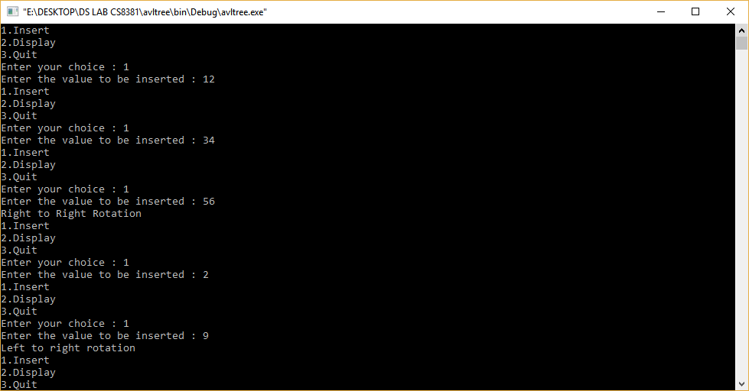

DEPARTMENT OF CSE Priyadarshini Engineering College Page 58

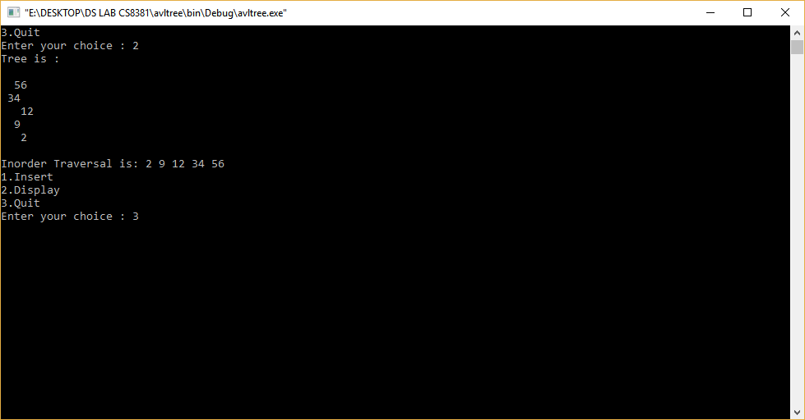

**RESULT**

Thus the ‘C’ program to implement an AVL trees . Produce its pre-Sequence, In-Sequence, and Post- Sequence traversals

DEPARTMENT OF CSE Priyadarshini Engineering College Page 59

# EXNO:8 IMPLEMENTATION OF PRIORITY QUEUE USING HEAPS

**AIM:**

To write a C program to implement Priority Queue using Binary Heaps.

**DESCRIPTION:**

A heap is a tree-based data structure in which all the nodes of the tree are in a specific order.

For example, if X is the parent node of Y, then the value of X follows a specific order with respect to the value of Y and the same order will be followed across the tree.

The maximum number of children of a node in a heap depends on the type of heap. However, in the more commonly-used heap type, there are at most 2 children of a node and it's known as a Binary heap

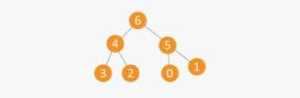

An array can be used to simulate a tree in the following way. If we are storing one element at index i in array Arr, then its parent will be stored at index i/2 (unless its a root, as root has no parent) and can be accessed by Arr[i/2], and its left child can be accessed by Arr[2∗i] and its right child can be accessed by Arr[2∗i+1]. Index of root will be 1 in an array.

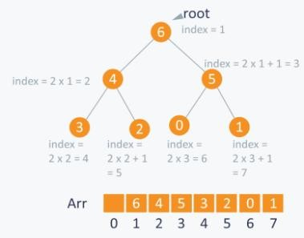

**ALGORITHM:**

* 1. Initialize all necessary variables and functions.
  2. Read the choices.
  3. For insertion, read the element to be inserted.
  4. If root is NULL, assign the given element as root.
  5. If the element is equal to the root, print “Duplicate value”.
  6. Else if element value is less than the root value, insert element at the left of the root.
  7. Else insert right side of the root.

DEPARTMENT OF CSE Priyadarshini Engineering College Page 60

* 1. For deletion, get the priority for maximum or minimum.
  2. If maximum, it deletes the root and rearranges the tree.
  3. If minimum, it deletes the leaf.
  4. End of the program

**PROGRAM**

#include<stdio.h> #include<conio.h> #include <stdlib.h> enum {FALSE=0,TRUE=-1};

struct Node

{

struct Node *Previous; int Data;

struct Node *Next;

}Current;

struct Node *head; struct Node *ptr; static int NumOfNodes;

int PriorityQueue(void); int Maximum(void);

int Minimum(void); void Insert(int); int Delete(int); void Display(void); int Search (int); void main()

{

int choice; int DT;

PriorityQueue();

while(1)

{

printf("\nEnter ur Choice:"); printf("\n1.Insert\n2.Display\n3.Delete\n4.Search\n5.Exit\n"); scanf("%d",&choice);

switch(choice)

{

case 1:

printf("\nEnter a data to enter Queue"); scanf("%d",&DT);

Insert(DT); break;

case 2:

Display(); break;

case 3:

{

int choice,DataDel; printf("\nEnter ur choice:");

printf("\n1.Maximum Priority queue\n2.Minimum priority Queue\n"); scanf("%d",&choice);

switch(choice)

{

DEPARTMENT OF CSE Priyadarshini Engineering College Page 61

case 1:

CS8381 DATA STRUCTURES LABORATORY

DataDel=Maximum(); Delete(DataDel);

printf("\n%d is deleted\n",DataDel); break;

case 2:

DataDel=Minimum(); Delete(DataDel);

printf("\n%d is deleted\n",DataDel); break;

default:

printf("\nSorry Not a correct Choice\n");

}

}

break; case 4:

printf("\nEnter a data to Search in Queue:"); scanf("%d",&DT);

if(Search(DT)!=FALSE)

printf("\n %d is present in queue",DT); else

printf("\n%d is not present in queue",DT); break;

case 5:

exit(0); default:

printf("\nCannot process ur choice\n");

} }}

int PriorityQueue(void)

{

Current.Previous=NULL;

printf("\nEnter first element of Queue:"); scanf("%d",&Current.Data); Current.Next=NULL;

head=&Current; ptr=head; NumOfNodes++; return;

}

int Maximum(void)

{

int Temp; ptr=head; Temp=ptr->Data;

while(ptr->Next!=NULL)

{

if(ptr->Data>Temp) Temp=ptr->Data;

ptr=ptr->Next;

}

if(ptr->Next==NULL && ptr->Data>Temp) Temp=ptr->Data;

return(Temp);

}

int Minimum(void)

{

int Temp; ptr=head; Temp=ptr->Data;

while(ptr->Next!=NULL)

DEPARTMENT OF CSE Priyadarshini Engineering College Page 62

{

if(ptr->Data<Temp) Temp=ptr->Data;

ptr=ptr->Next;

}

if(ptr->Next==NULL && ptr->Data<Temp) Temp=ptr->Data;

return(Temp);

}

void Insert(int DT)

{

struct Node *newnode;

newnode=(struct Node *)malloc(sizeof(struct Node)); newnode->Next=NULL;

newnode->Data=DT; while(ptr->Next!=NULL)

ptr=ptr->Next; if(ptr->Next==NULL)

{

newnode->Next=ptr->Next; ptr->Next=newnode;

}

NumOfNodes++;

}

int Delete(int DataDel)

{

struct Node *mynode,*temp; ptr=head;

if(ptr->Data==DataDel)

{

temp=ptr; ptr=ptr->Next;

ptr->Previous=NULL; head=ptr;

NumOfNodes--; return(TRUE);

}

else

{

while(ptr->Next->Next!=NULL)

{

if(ptr->Next->Data==DataDel)

{

mynode=ptr; temp=ptr->Next;

mynode->Next=mynode->Next->Next; mynode->Next->Previous=ptr; free(temp);

NumOfNodes--; return(TRUE);

}

ptr=ptr->Next;

}

if(ptr->Next->Next==NULL && ptr->Next->Data==DataDel)

{

temp=ptr->Next; free(temp);

ptr->Next=NULL; NumOfNodes--;

DEPARTMENT OF CSE Priyadarshini Engineering College Page 63

DEPARTMENT OF CSE Priyadarshini Engineering College Page 64

return(TRUE);

}

}

return(FALSE);

}

int Search(int DataSearch)

{

ptr=head;

while(ptr->Next!=NULL)

{

if(ptr->Data==DataSearch) return ptr->Data;

ptr=ptr->Next;

}

if(ptr->Next==NULL && ptr->Data==DataSearch) return ptr->Data;

return(FALSE);

}

void Display(void)

{

ptr=head;

printf("\nPriority Queue is as Follows:-\n"); while(ptr!=NULL)

{

printf("\t\t%d",ptr->Data); ptr=ptr->Next;

}

}

**OUTPUT**

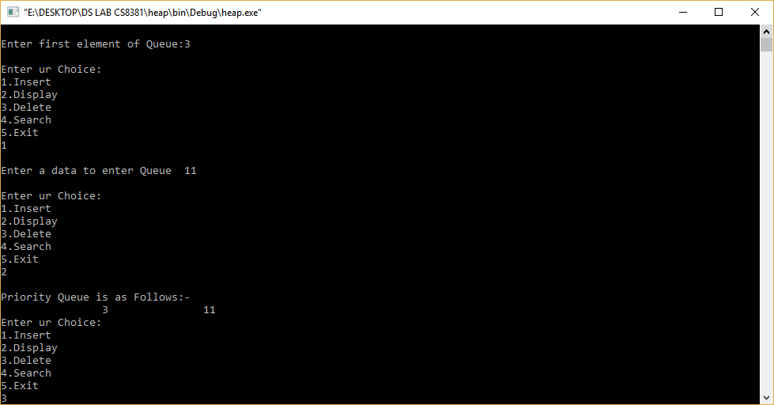

DEPARTMENT OF CSE Priyadarshini Engineering College Page 65

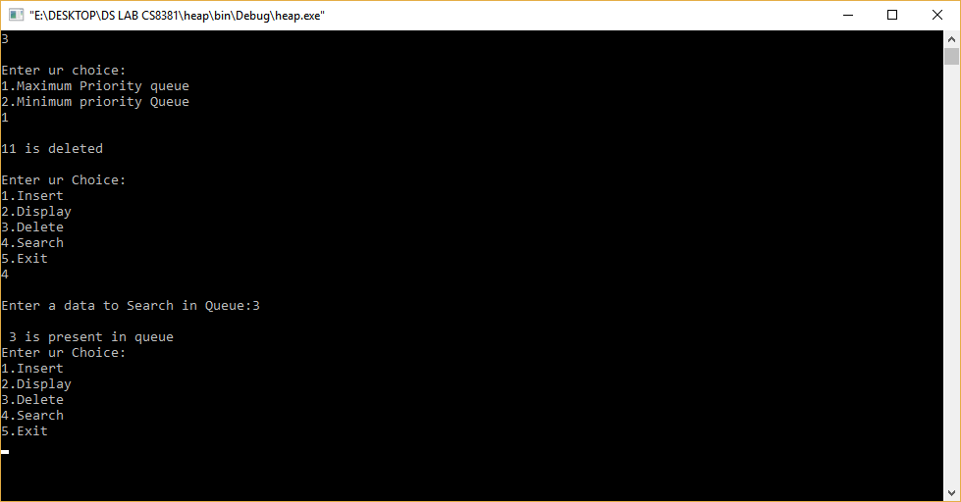

**RESULT:**

Thus the Priority Queue using Binary Heap is implemented and the result is verified successfully.

DEPARTMENT OF CSE Priyadarshini Engineering College Page 66

**EX : 9 IMPLEMENTATION OF PRIM’S ALGORITHM**

**AIM:**

To implement the prim’s algorithm in c program.

**ALGORITHM:**

**1.**Determine an arbitrary vertex as the starting vertex of the MST.

2.Follow steps 3 to 5 till there are vertices that are not included in the MST

3.Find the edges connecting any tree vertex with the fringe vertices.

4.Find the minimum among these edges.

5.Add the chosen edge to the MST if it does not form any cycle.

6.return the MST and exit.

**PROGRAM:**

#include<stdio.h>

#include<stdlib.h>

#define infinity 9999

#define MAX 20

**int** G[MAX][MAX],spanning[MAX][MAX],n;

**int** prims();

**int** main()

{

**int** i,j,total_cost;

printf("Enter no. of vertices:");

scanf("%d",&n);

printf("\nEnter the adjacency matrix:\n");

**for**(i=0;i<n;i++)

**for**(j=0;j<n;j++)

scanf("%d",&G[i][j]);

total_cost=prims();

printf("\nspanning tree matrix:\n");

**for**(i=0;i<n;i++)

{

printf("\n");

**for**(j=0;j<n;j++)

printf("%d\t",spanning[i][j]);

}

printf("\n\nTotal cost of spanning tree=%d",total_cost);

**return** 0;

}

**int** prims()

{

**int** cost[MAX][MAX];

**int** u,v,min_distance,distance[MAX],from[MAX];

**int** visited[MAX],no_of_edges,i,min_cost,j;

**for**(i=0;i<n;i++)

**for**(j=0;j<n;j++)

{

**if**(G[i][j]==0)

cost[i][j]=infinity;

**else**

cost[i][j]=G[i][j];

spanning[i][j]=0;

}

distance[0]=0;

visited[0]=1;

**for**(i=1;i<n;i++)

{

distance[i]=cost[0][i];

from[i]=0;

visited[i]=0;

}

min_cost=0;

no_of_edges=n-1;

**while**(no_of_edges>0)

{

min_distance=infinity;

**for**(i=1;i<n;i++)

**if**(visited[i]==0&&distance[i]<min_distance)

{

v=i;

min_distance=distance[i];

}

u=from[v];

spanning[u][v]=distance[v];

spanning[v][u]=distance[v];

no_of_edges--;

visited[v]=1;

**for**(i=1;i<n;i++)

**if**(visited[i]==0&&cost[i][v]<distance[i])

{

distance[i]=cost[i][v];

from[i]=v;

}

min_cost=min_cost+cost[u][v];

}

**return**(min_cost);

}

**Output**

*Enter no. of vertices:6*  
  
*Enter the adjacency matrix:*  
*0 3 1 6 0 0*  
*3 0 5 0 3 0*  
*1 5 0 5 6 4*  
*6 0 5 0 0 2*  
*0 3 6 0 0 6*  
*0 0 4 2 6 0*  
  
*spanning tree matrix:*  
*0 3 1 0 0 0*  
*3 0 0 0 3 0*  
*1 0 0 0 0 4*  
*0 0 0 0 0 2*  
*0 3 0 0 0 0*  
*0 0 4 2 0 0*  
  
*Total cost of spanning tree=13*

# Ex:10.A GRAPH REPRESENTATIONS

**AIM**:

To write a C program implement adjacent matrix and adjacency list .

**DESCRIPTION:**

Graph is a data structure that sconsists of following two components:

1. A finite set of vertices also called as nodes.
2. A finite set of ordered pair of the form (u, v) called as edge. The pair is ordered because (u, v) is not same as (v, u) in case of a directed graph(di-graph). The pair of the form (u, v) indicates that there is an edge from vertex u to vertex v. The edges may contain weight/value/cost.

Following two are the most commonly used representations of a graph.

1. Adjacency Matrix
2. Adjacency List

There are other representations also like, Incidence Matrix and Incidence List. The choice of the graph representation is situation specific. It totally depends on the type of operations to be performed and ease of use.

# Adjacency Matrix:

Adjacency Matrix is a 2D array of size V x V where V is the number of vertices in a graph. Let the 2D array be adj[][], a slot adj[i][j] = 1 indicates that there is an edge from vertex i to vertex j. Adjacency matrix for undirected graph is always symmetric. Adjacency Matrix is also used to represent weighted graphs. If adj[i][j] = w, then there is an edge from vertex i to vertex j with weigh t w’.

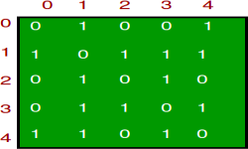The adjacency matrix for the above example graph is:

# Adjacency List:

An array of linked lists is used. Size of the array is equal to the number of vertices. Let the array be array[]. An entry array[i] represents the linked list of vertices adjacent to the ***i***th vertex. This representation can also be used to represent a weighted graph. The weights of edges can be stored in nodes of linked lists. Following is adjacency list representation of the above graph..

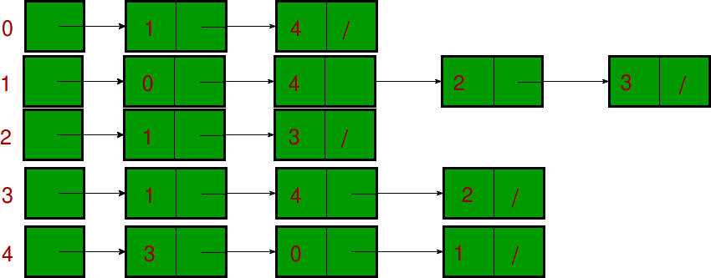

**ALGORITHM:**

1. Create a graph with getting no. of vertices and no. of edges
2. Implement adjacency matrix
3. Implement adjacency list
4. Close the program

**PROGRAM**

#include <stdio.h> #include <stdlib.h> void main()

{ int option; do

{printf("\n A Program to represent a Graph by using an "); printf("Adjacency Matrix method \n ");

printf("\n 1. Directed Graph "); printf("\n 2. Un-Directed Graph "); printf("\n 3. Exit ");

printf("\n\n Select a proper option : "); scanf("%d", &option);

switch(option)

{

DEPARTMENT OF CSE Priyadarshini Engineering College Page 67

case 1 : dir_graph();

break;

case 2 : undir_graph(); break;

case 3 : exit(0);

} // switch

}while(1);

}

int dir_graph()

{

int adj_mat[50][50]; int n;

int in_deg, out_deg, i, j; printf("\n How Many Vertices ? : "); scanf("%d", &n);

read_graph(adj_mat, n);

printf("\n Vertex \t In_Degree \t Out_Degree \t Total_Degree "); for (i = 1; i <= n ; i++ )

{

in_deg = out_deg = 0;

for ( j = 1 ; j <= n ; j++ )

{

if ( adj_mat[j][i] == 1 ) in_deg++;}

for ( j = 1 ; j <= n ; j++ ) if (adj_mat[i][j] == 1 )

DEPARTMENT OF CSE Priyadarshini Engineering College Page 68

out_deg++;

printf("\n\n

%5d\t\t\t%d\t\t%d\t\t%d\n\n",i,in_deg,out_deg,in_deg+out_deg);

}return;}

int undir_graph()

{

int adj_mat[50][50]; int deg, i, j, n;

printf("\n How Many Vertices ? : "); scanf("%d", &n);

read_graph(adj_mat, n);

printf("\n Vertex \t Degree "); for ( i = 1 ; i <= n ; i++ )

{

deg = 0;

for ( j = 1 ; j <= n ; j++ ) if ( adj_mat[i][j] == 1)

deg++;

printf("\n\n %5d \t\t %d\n\n", i, deg);

}

return;}

int read_graph ( int adj_mat[50][50], int n )

{

int i, j; char reply;

for ( i = 1 ; i <= n ; i++ )

DEPARTMENT OF CSE Priyadarshini Engineering College Page 69

DEPARTMENT OF CSE Priyadarshini Engineering College Page 70

{

for ( j = 1 ; j <= n ; j++ )

{

if ( i == j )

{

adj_mat[i][j] = 0; continue;

}

printf("\n Vertices %d & %d are Adjacent ? (Y/N) :",i,j); scanf("%c", &reply);

if ( reply == 'y' || reply == 'Y' ) adj_mat[i][j] = 1;

else

adj_mat[i][j] = 0;

}}

return;}

OUTPUT

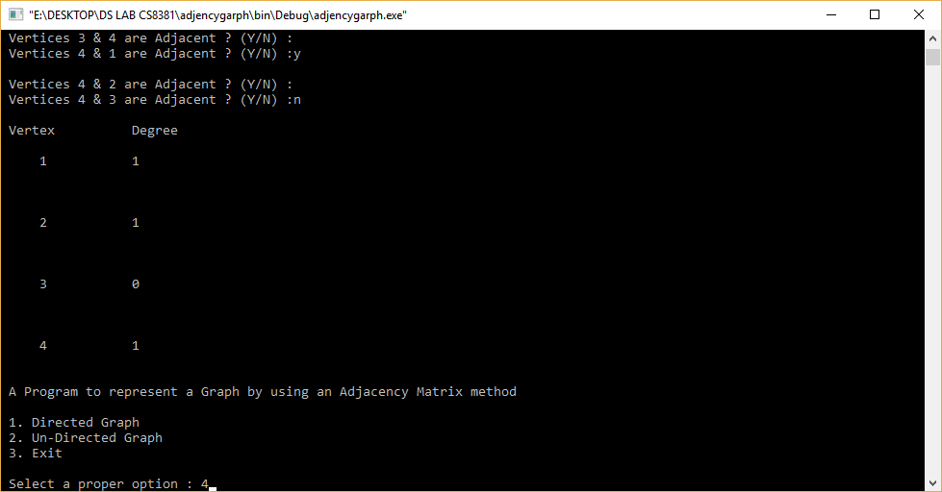

CS8381 DATA STRUCTURES LABORATORY

**RESULT:**

Thus the C program implemented adjacent matrix and adjacency list

DEPARTMENT OF CSE Priyadarshini Engineering College Page 71

**EX.NO.10.B** Implement DFS and BFS graph traversal

CS8381 DATA STRUCTURES LABORATORY

**Aim**:

To write a C program implement DFS and BFS graph traversal**.**

**DESCRIPTION:**

[Depth First Traversal (or Search)](http://en.wikipedia.org/wiki/Depth-first_search) for a graph is similar to [Depth First Traversal of a tree](https://www.geeksforgeeks.org/archives/618). The only catch here is, unlike trees, graphs may contain cycles, so we may come to the same node again. To avoid processing a node more than once, we use a boolean visited array.

For example, in the following graph, we start traversal from vertex 2. When we come to vertex 0, we look for all adjacent vertices of it. 2 is also an adjacent vertex of 0. If we don’t mark visited vertices, then 2 will be processed again and it will become a non-terminating process. A Depth First Traversal of the following graph is 2, 0, 1, 3.

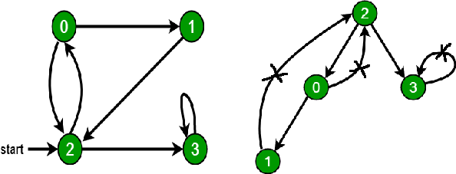

Breadth First Search or BFS for a Graph

[Breadth First Traversal (or Search)](http://en.wikipedia.org/wiki/Breadth-first_search) for a graph is similar to Breadth First Traversal of a tree (See method 2 of [this post](https://www.geeksforgeeks.org/archives/2686)). The only catch here is, unlike trees, graphs may contain cycles, so we may come to the same node again. To avoid processing a node more than once, we use a boolean visited array. For simplicity, it is assumed that all vertices are reachable from the starting vertex.

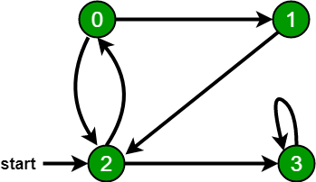For example, in the following graph, we start traversal from vertex 2. When we come to vertex 0, we look for all adjacent vertices of it. 2 is also an adjacent vertex of 0. If we don’t mark visited vertices, then 2 will be processed again and it will become a non-terminating process. A Breadth First Traversal of the following graph is 2, 0, 3, 1.

**ALGORITHM:**

**DFS**

1. Define a Stack of size total number of vertices in the graph.
2. Select any vertex as starting point for traversal. Visit that vertex and push it on to the Stack.
3. Visit any one of the adjacent vertex of the verex which is at top of the stack which is not visited and push it on to the stack.
4. Repeat step 3 until there are no new vertex to be visit from the vertex on top of the stack.
5. When there is no new vertex to be visit then use back tracking and pop one vertex from the stack.
6. Repeat steps 3, 4 and 5 until stack becomes Empty.

DEPARTMENT OF CSE Priyadarshini Engineering College Page 72

1. When stack becomes Empty, then produce final spanning tree by removing unused edges from the graph

# BFS

1. Define a Queue of size total number of vertices in the graph.
2. Select any vertex as starting point for traversal. Visit that vertex and insert it into the Queue.
3. Visit all the adjacent vertices of the verex which is at front of the Queue which is not visited and insert them into the Queue.
4. When there is no new vertex to be visit from the vertex at front of the Queue then delete that vertex from the Queue.
5. Repeat step 3 and 4 until queue becomes empty.
6. When queue becomes Empty, then produce final spanning tree by removing unused edges from the graph

**PROGRAM**

include<stdio.h>

int q[20],top=-1,front=-1,rear=-1,a[20][20],vis[20],stack[20]; int delete();

void add(int item); void bfs(int s,int n); void dfs(int s,int n); void push(int item); int pop();

void main()

{

int n,i,s,ch,j; char c,dummy;

printf("ENTER THE NUMBER VERTICES ");

scanf("%d",&n); for(i=1;i<=n;i++)

{

for(j=1;j<=n;j++)

{

printf("ENTER 1 IF %d HAS A NODE WITH %d ELSE 0 ",i,j);

scanf("%d",&a[i][j]);

}

}

DEPARTMENT OF CSE Priyadarshini Engineering College Page 73

printf("THE ADJACENCY MATRIX IS\n");

for(i=1;i<=n;i++)

{

for(j=1;j<=n;j++)

{

printf(" %d",a[i][j]);

}

printf("\n");

}

do

{

for(i=1;i<=n;i++) vis[i]=0; printf("\nMENU"); printf("\n1.B.F.S");

printf("\n2.D.F.S"); printf("\nENTER YOUR CHOICE");

scanf("%d",&ch);

printf("ENTER THE SOURCE VERTEX :");

scanf("%d",&s);

switch(ch)

{

case 1:bfs(s,n); break;

case 2:

dfs(s,n); break;

}

printf("DO U WANT TO CONTINUE(Y/N) ? ");

scanf("%c",&dummy);

scanf("%c",&c);

DEPARTMENT OF CSE Priyadarshini Engineering College Page 74

}while((c=='y')||(c=='Y'));

}

//**************BFS(breadth-first search) code**************// void bfs(int s,int n)

{

int p,i; add(s);

vis[s]=1; p=delete(); if(p!=0) printf(" %d",p); while(p!=0)

{

for(i=1;i<=n;i++) if((a[p][i]!=0)&&(vis[i]==0))

{

add(i);

vis[i]=1;

}

p=delete(); if(p!=0) printf(" %d ",p);

}

for(i=1;i<=n;i++) if(vis[i]==0)

bfs(i,n);

}

void add(int item)

{

if(rear==19) printf("QUEUE FULL"); else

{

if(rear==-1)

DEPARTMENT OF CSE Priyadarshini Engineering College Page 75

{

CS8381 DATA STRUCTURES LABORATORY

q[++rear]=item; front++;

}

else q[++rear]=item;

}

}

int delete()

{

int k; if((front>rear)||(front==-1)) return(0);

else

{

k=q[front++]; return(k);

}

}

//***************DFS(depth-first search) code******************// void dfs(int s,int n)

{

int i,k; push(s);

vis[s]=1;

k=pop();

if(k!=0) printf(" %d ",k); while(k!=0)

{

for(i=1;i<=n;i++) if((a[k][i]!=0)&&(vis[i]==0))

{push(i);

vis[i]=1;

DEPARTMENT OF CSE Priyadarshini Engineering College Page 76

DEPARTMENT OF CSE Priyadarshini Engineering College Page 77

}

CS8381 DATA STRUCTURES LABORATORY

k=pop();

if(k!=0) printf(" %d ",k);

}

for(i=1;i<=n;i++) if(vis[i]==0)

dfs(i,n);

}

void push(int item)

{

if(top==19)

printf("Stack overflow "); else

stack[++top]=item;

}

int pop()

{

int k; if(top==-1) return(0); else

{

k=stack[top--]; return(k);

}

}

**OUTPUT**

CS8381 DATA STRUCTURES LABORATORY

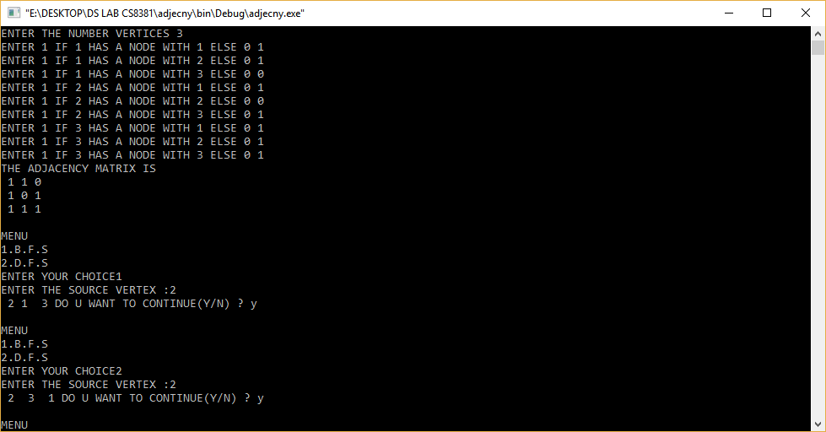

**RESULT**:

Thus the C program implemented DFS and BFS graph traversal.

DEPARTMENT OF CSE Priyadarshini Engineering College Page 78

Ex:11.A. IMPLEMENTATION OF SEARCHING ALGORITHMS LINEAR SEARCH AND BINARY SEARCH

CS8381 DATA STRUCTURES LABORATORY

**AIM:**

To write a C Program to implement different searching techniques – Linear and Binary search.

**DESCRIPTION:**

Binary search however, cut down your search to half as soon as you find middle of a sorted list.The middle element is looked to check if it is greater than or less than the value to be searched.Accordingly, search is done to either half of the given list

# Linear Search to find the element “J” in a given sorted list from A-X

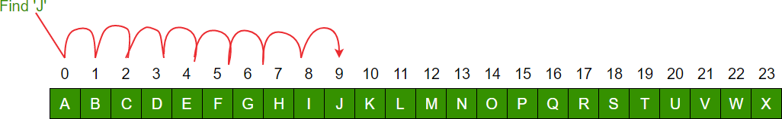

**Binary Search to find the element “J” in a given sorted list from A-X**

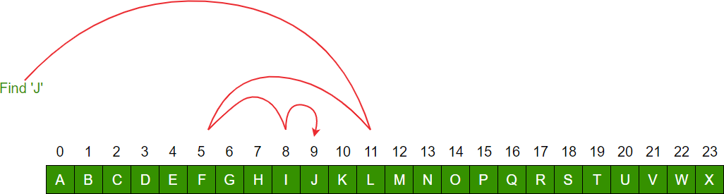

**ALGORITHM:**

**Linear Search**:

1. Read the search element from the user
2. Compare, the search element with the first element in the list.
3. If both are matching, then display "Given element found!!!" and terminate the function
4. If both are not matching, then compare search element with the next element in the list.
5. Repeat steps 3 and 4 until the search element is compared with the last element in the list.
6. If the last element in the list is also doesn't match, then display "Element not found!!!" and terminate the function.

# Binary search is implemented using following steps...

1. Read the search element from the user
2. Find the middle element in the sorted list
3. Compare, the search element with the middle element in the sorted list.

DEPARTMENT OF CSE Priyadarshini Engineering College Page 79

1. If both are matching, then display "Given element found!!!" and terminate the function

CS8381 DATA STRUCTURES LABORATORY

1. If both are not matching, then check whether the search element is smaller or larger than middle element.
2. If the search element is smaller than middle element, then repeat steps 2, 3, 4 and 5 for the left sublist of the middle element.
3. If the search element is larger than middle element, then repeat steps 2, 3, 4 and 5 for the right sublist of the middle element.
4. Repeat the same process until we find the search element in the list or until sublist contains only one element.
5. If that element also doesn't match with the search element, then display "Element not found in the list!!!" and terminate the function.

**PROGRAM**

#include <stdio.h>

void sequential_search(int array[], int size, int n)

{

int i;

for (i = 0; i < size; i++)

{

if (array[i] == n)

{

printf("%d found at location %d.\n", n, i+1); break;

}

}

if (i == size)

printf("Not found! %d is not present in the list.\n", n);

}

void binary_search(int array[], int size, int n)

{

int i, first, last, middle; first = 0;

last = size - 1;

middle = (first+last) / 2;

while (first <= last) {

if (array[middle] < n) first = middle + 1;

else if (array[middle] == n) {

printf("%d found at location %d.\n", n, middle+1); break;

}

else

last = middle - 1;

middle = (first + last) / 2;

}

if ( first > last )

printf("Not found! %d is not present in the list.\n", n);

DEPARTMENT OF CSE Priyadarshini Engineering College Page 80

}

CS8381 DATA STRUCTURES LABORATORY

int main()

{

int a[200], i, j, n, size; printf("Enter the size of the list:"); scanf("%d", &size);

printf("Enter %d Integers in ascending order\n", size); for (i = 0; i < size; i++)

scanf("%d", &a[i]); printf("Enter value to find\n"); scanf("%d", &n); printf("Sequential search\n"); sequential_search(a, size, n); printf("Binary search\n"); binary_search(a, size, n); return 0;

}

**OUTPUT**

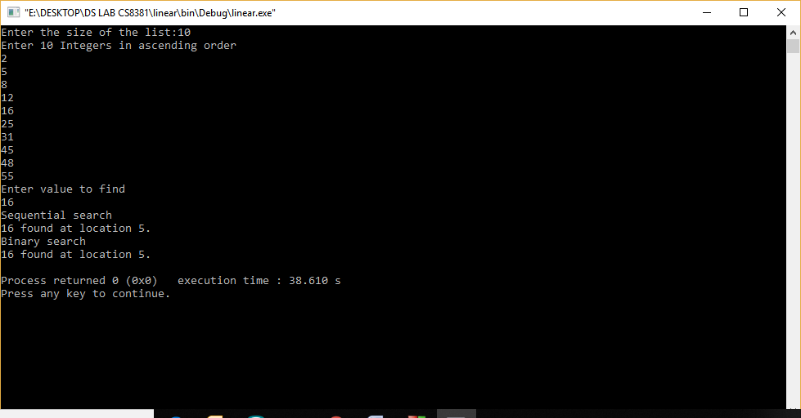

**RESULT**

Thus the C Program to implement different searching techniques – Linear and Binary search

DEPARTMENT OF CSE Priyadarshini Engineering College Page 81

# Ex. No:11.B.1 BUBBLE SORT

CS8381 DATA STRUCTURES LABORATORY

**AIM:**

To write a C program to implement the concept of bubble sort

**DESCRIPTION:**

* Bubble sort is one of the simplest internal sorting algorithms.
* Bubble sort works by comparing two consecutive elements and the largest elementamong these two bubbles towards right at the end of the first pass the largest element gets sorted and placed at the end of the sorted list.
* This process is repeated for all pairs of elements until it moves the largest element to the end of the list in that iteration.
* Bubble sort consists of (n-1) passes, where n is the number of elements to be sorted.
* In 1st pass the largest element will be placed in the nth position.
* In 2nd pass the second largest element will be placed in the (n-1)th position. In (n-1)th pass only the first two elements are compared.

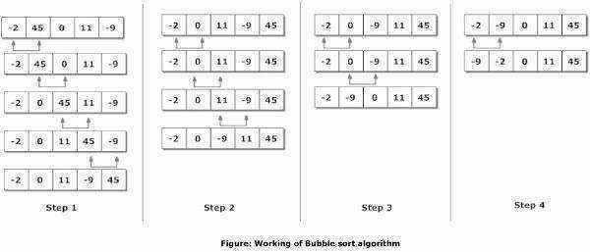

**ALGORITHM:**

1: Start.

2: Repeat Steps 3 and 4 for i=1 to 10

3: Set j=1

4: Repeat while j<=n

* 1. if a[i] < a[j]

Then interchange a[i] and a[j] [End of if]

DEPARTMENT OF CSE Priyadarshini Engineering College Page 82

DEPARTMENT OF CSE Priyadarshini Engineering College Page 83

* 1. Set j = j+1

[End of Inner Loop] [End of Step 1 Outer Loop]

5: Stop.

**PROGRAM:**

#include<stdio.h> #include<conio.h> void main(){

int n, i, j, temp , a[100];

printf("Enter the total integers you want to enter (make it less than 100):\n"); scanf("%d",&n);

printf("Enter the %d integer array elements:\n",n); for(i=0;i<n;i++){

scanf("%d",&a[i]);

}

for(i=0;i<n-1;i++){

for(j=0;j<n-i-1;j++){

if(a[j+1]<a[j]){ temp = a[j]; a[j] = a[j+1]; a[j+1] = temp;

}}}

printf("The sorted numbers are:"); for(i=0;i<n;i++){ printf("%3d",a[i]);

}getch();

}

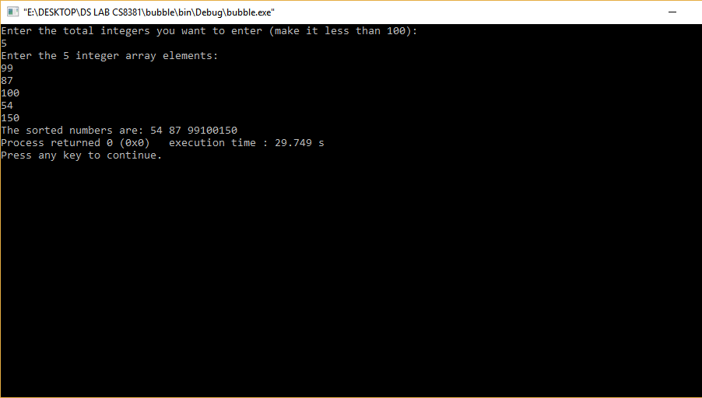**OUTPUT**

**RESULT:**

Thus a C program for the concept of bubble sort was implemented successfull

DEPARTMENT OF CSE Priyadarshini Engineering College Page 84

# Ex. No:11.B.2 MERGE SORT AIM:

CS8381 DATA STRUCTURES LABORATORY

To write a C program to implement the concept of merge sort.

**DESCRIPTION:**

Merge sort is a sorting algorithm that uses the divide, conquer, and combine algorithmic paradigm. Divide means partitioning the n-element array to be sorted into two sub-arrays of n/2 elements.

If there are more elements in the array, divide A into two sub-arrays, A1 and A2, each containing about half of the elements of A.

Conquer means sorting the two sub-arrays recursively using merge sort.

Combine means merging the two sorted sub-arrays of size n/2 to produce the sorted array of n elements. The basic steps of a merge sort algorithm are as follows:

* + 1. If the array is of length 0 or 1, then it is already sorted.
    2. Otherwise, divide the unsorted array into two sub-arrays of about half the size. Use merge sort algorithm recursively to sort each sub-array.



Merge the two sub-arrays to form a single sorted list

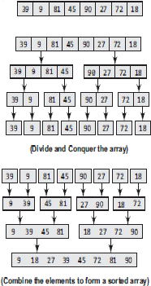

**ALGORITHM:**

1: Start.

2: First you divide the number of elements by 2 and seperate them as two. 3: Divide those two which are divided by 2.

4: Divide them until you get a single element.

5: Start comparing the starting two pair of elements with each other and place them in ascending order.

DEPARTMENT OF CSE Priyadarshini Engineering College Page 85

6: When you combine them compare them so that you make sure they are sorted.

7: When all the elements are compared the array will be surely sorted in an ascending order. 8: Stop.

## PROGRAM:

#include<stdio.h> #include<conio.h>

void merge(int [],int ,int ,int ); void part(int [],int ,int );

void main(){ int arr[30]; int i,size;

printf("\n\t------- Merge sorting method \n\n");

printf("Enter total no. of elements : "); scanf("%d",&size);

for(i=0; i<size; i++){ printf("Enter %d element : ",i+1); scanf("%d",&arr[i]);

}

part(arr,0,size-1);

printf("\n\t------- Merge sorted elements \n\n");

for(i=0; i<size; i++) printf("%d ",arr[i]); getch();

}

void part(int arr[],int min,int max){ int mid;

if(min<max){ mid=(min+max)/2; part(arr,min,mid); part(arr,mid+1,max); merge(arr,min,mid,max);}}

void merge(int arr[],int min,int mid,int max){ int tmp[30];

DEPARTMENT OF CSE Priyadarshini Engineering College Page 86

int i,j,k,m; j=min; m=mid+1;

DEPARTMENT OF CSE Priyadarshini Engineering College Page 87

for(i=min; j<=mid && m<=max ; i++){ if(arr[j]<=arr[m]){

tmp[i]=arr[j]; j++;}

else{ tmp[i]=arr[m]; m++;

}}

if(j>mid){

for(k=m; k<=max; k++){ tmp[i]=arr[k];

i++;

}}

else{

for(k=j; k<=mid; k++){ tmp[i]=arr[k];

i++;

}}

for(k=min; k<=max; k++) arr[k]=tmp[k]; }

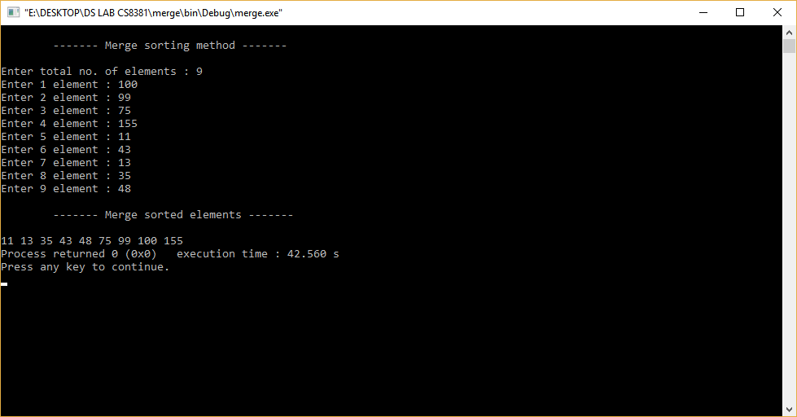**OUTPUT**

CS8381 DATA STRUCTURES LABORATORY

**RESULT:**

Thus a C program for the concept of merge sort was implemented successfully.

DEPARTMENT OF CSE Priyadarshini Engineering College Page 88

# Ex. No:11.B.3 QUICK SORT AIM:

To write a C program to implement the concept of Quick sort.

**DESCRIPTION:**

Quick Sort, as the name suggests, sorts any list very quickly. Quick sort is not stable search, but it is very fast and requires very less additional space. It is based on the rule of Divide and Conquer (also called partition-exchange sort). This algorithm divides the list into three main parts:

* Elements less than the Pivot element
* Pivot element
* Elements greater than the pivot element

**ALGORITHM:**

1: Start.

2: Choose any element of the array to be the pivot.

3: Divide all other elements (except the pivot) into two partitions.

* All elements less than the pivot must be in the first partition.
* All elements greater than the pivot must be in the second partition.

4: Use recursion to sort both partitions.

5: Join the first sorted partition, the pivot, and the second sorted partition. 6: Stop

**PROGRAM:**

#include<stdio.h> #include<conio.h>

void qsort(int arr[20], int fst, int last); void main(){

int arr[30]; int i,size;

DEPARTMENT OF CSE Priyadarshini Engineering College Page 89

printf("Enter total no. of the elements : "); scanf("%d",&size);

printf("Enter total %d elements : \n",size); for(i=0; i<size; i++)

scanf("%d",&arr[i]); qsort(arr,0,size-1);

printf("Quick sorted elements are as : \n"); for(i=0; i<size; i++)

printf("%d\t",arr[i]); getch();}

void qsort(int arr[20], int fst, int last){ int i,j,pivot,tmp;

if(fst<last){ pivot=fst; i=fst; j=last; while(i<j){

while(arr[i]<=arr[pivot] && i<last) i++;

while(arr[j]>arr[pivot]) j--;

if(i<j){ tmp=arr[i]; arr[i]=arr[j];

arr[j]=tmp;}} tmp=arr[pivot]; arr[pivot]=arr[j];

DEPARTMENT OF CSE Priyadarshini Engineering College Page 90

arr[j]=tmp; qsort(arr,fst,j-1); qsort(arr,j+1,last);

} }

**OUTPUT**

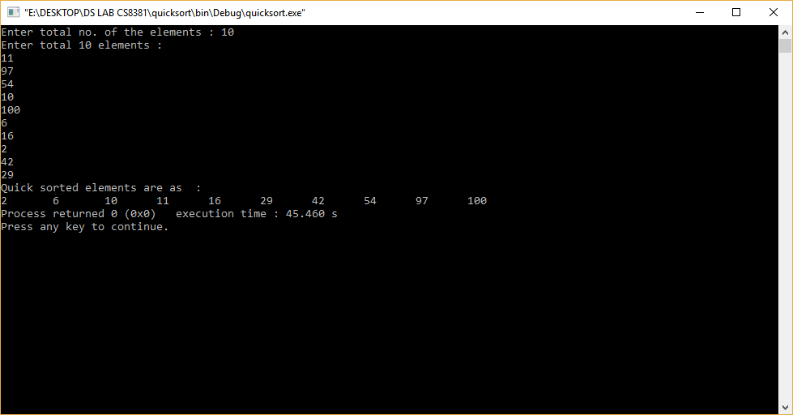

**RESULT:**

Thus the C program to implement the concept of Quick sort.

DEPARTMENT OF CSE Priyadarshini Engineering College Page 91

DEPARTMENT OF CSE Priyadarshini Engineering College Page 92

# Ex. No: 11 HASHING TECHNIQUES

**AIM**: To write a C program to implement hash table

**DESCRIPTION:**

**Hashing**

Hashing is a technique to convert a range of key values into a range of indexes of an array. We're going to use modulo operator to get a range of key values. Consider an example of hash table of size 20, and the following items are to be stored. Item are in the (key,value) format.

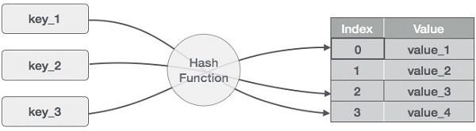

* (1,20)
* (2,70)
* (42,80)
* (4,25)
* (12,44)
* (14,32)
* (17,11)
* (13,78)
* (37,98)

|  |  |  |  |
| --- | --- | --- | --- |
| **Sr.No.** | **Key** | **Hash** | **Array Index** |
| 1 | 1 | 1 % 20 = 1 | 1 |
| 2 | 2 | 2 % 20 = 2 | 2 |
| 3 | 42 | 42 % 20 = 2 | 2 |
| 4 | 4 | 4 % 20 = 4 | 4 |
| 5 | 12 | 12 % 20 = 12 | 12 |
| 6 | 14 | 14 % 20 = 14 | 14 |
| 7 | 17 | 17 % 20 = 17 | 17 |
| 8 | 13 | 13 % 20 = 13 | 13 |
| 9 | 37 | 37 % 20 = 17 | 17 |

**ALGORITHM:**

CS8381 DATA STRUCTURES LABORATORY

1. Create a structure, data (hash table item) with key and value as data.
2. Now create an array of structure, data of some certain size (10, in this case). But, the size of array must be immediately updated to a prime number just greater than initial array capacity (i.e 10, in this case).
3. A menu is displayed on the screen.
4. User must choose one option from four choices given in the menu
5. Perform all the operations
6. Stop the program

**PROGRAM**

#include<stdio.h> #include<stdlib.h> struct data

{

int key; int value;

};

struct data *array; int capacity = 10; int size = 0;

/* this function gives a unique hash code to the given key */ int hashcode(int key)

{

return (key % capacity);

}

/* it returns prime number just greater than array capacity */ int get_prime(int n)

{

if (n % 2 == 0)

{

DEPARTMENT OF CSE Priyadarshini Engineering College Page 93

n++;

}

}

for (; !if_prime(n); n += 2); return n;

/* to check if given input (i.e n) is prime or not */ int if_prime(int n)

{

int i;

if ( n == 1 || n == 0)

{

return 0;

}

for (i = 2; i < n; i++)

{

if (n % i == 0)

{

return 0;}}

return 1;

}

void init_array()

{

int i;

capacity = get_prime(capacity);

array = (struct data*) malloc(capacity * sizeof(struct data)); for (i = 0; i < capacity; i++)

{

array[i].key = 0;

array[i].value = 0;

}}

/* to insert a key in the hash table */ void insert(int key)

{

int index = hashcode(key);

DEPARTMENT OF CSE Priyadarshini Engineering College Page 94

if (array[index].value == 0)

{

/* key not present, insert it */ array[index].key = key; array[index].value = 1;

size++;

printf("\n Key (%d) has been inserted \n", key);

}

else if(array[index].key == key)

{

/* updating already existing key */

printf("\n Key (%d) already present, hence updating its value \n", key); array[index].value += 1;

}

else

{

/* key cannot be insert as the index is already containing some other key*/ printf("\n ELEMENT CANNOT BE INSERTED \n");

}}

/* to remove a key from hash table */ void remove_element(int key)

{

int index = hashcode(key); if(array[index].value == 0)

{

}

else {

printf("\n This key does not exist \n");

array[index].key = 0;

array[index].value = 0; size--;

printf("\n Key (%d) has been removed \n", key);}}

/* to display all the elements of a hash table */ void display()

DEPARTMENT OF CSE Priyadarshini Engineering College Page 95

{

int i;for (i = 0; i < capacity; i++)

{

if (array[i].value == 0)

{

printf("\n Array[%d] has no elements \n");

}

else

{

printf("\n array[%d] has elements -:\n key(%d) and value(%d) \t", i, array[i].key, array[i].value);

}}}

int size_of_hashtable()

{

return size;

}

void main()

{

int choice, key, value, n, c; init_array();

do {

printf("\n Implementation of Hash Table in C \n\n"); printf("MENU-: \n1.Inserting item in the Hash Table"

"\n2.Removing item from the Hash Table" "\n3.Check the size of Hash Table"

"\n4.Display a Hash Table" "\n\n Please enter your choice -:");

scanf("%d", &choice); switch(choice)

{

case 1:

printf("Inserting element in Hash Table\n"); printf("Enter key -:\t");

scanf("%d", &key);

DEPARTMENT OF CSE Priyadarshini Engineering College Page 96

DEPARTMENT OF CSE Priyadarshini Engineering College Page 97

insert(key);

break;

case 2:

printf("Deleting in Hash Table \n Enter the key to delete-:"); scanf("%d", &key);

remove_element(key); break;

case 3:

n = size_of_hashtable();

printf("Size of Hash Table is-:%d\n", n); break;

case 4:

display(); break;

default:

printf("Wrong Input\n");}

printf("\n Do you want to continue-:(press 1 for yes)\t"); scanf("%d", &c);

}while(c == 1);

getch();}

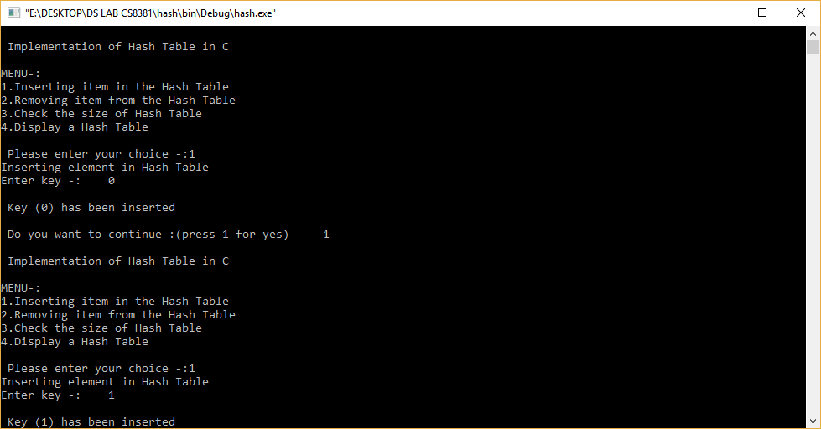**OUTPUT**

CS8381 DATA STRUCTURES LABORATORY

DEPARTMENT OF CSE Priyadarshini Engineering College Page 98

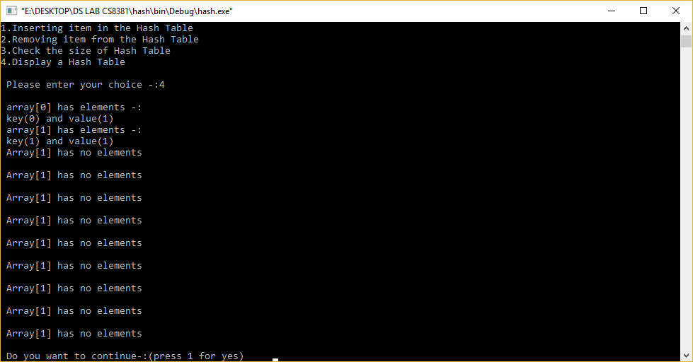

**RESULT**: Thus the C program to implemented Hash Table.

**EX: 12 Implementation of Dijkstra's Algorithm**

**AIM:**

To implement the Dijkstra’s Algorthim in the C program.

**ALGORTHIM:**

**1.** Mark the ending vertex with a distance of zero. Designate this vertex as current.

2.Find all vertices leading to the current vertex. Calculate their distances to the end. ...

3.Mark the current vertex as visited. ...

4.Mark the vertex with the smallest distance as current, and repeat from step 2.

**PROGRAM:**

#include <stdio.h>

#define INF 9999

#define MAX 10

**void** DijkstraAlgorithm(**int** Graph[MAX][MAX], **int** size, **int** start);

**void** DijkstraAlgorithm(**int** Graph[MAX][MAX], **int** size, **int** start) {

**int** cost[MAX][MAX], distance[MAX], previous[MAX];

**int** visited_nodes[MAX], counter, minimum_distance, next_node, i, j;

**for** (i = 0; i < size; i++)

**for** (j = 0; j < size; j++)

**if** (Graph[i][j] == 0)

        cost[i][j] = INF;

**else**

      cost[i][j] = Graph[i][j];

**for** (i = 0; i < size; i++) {

      distance[i] = cost[start][i];

     previous[i] = start;

     visited_nodes[i] = 0;

   }

   distance[start] = 0;

   visited_nodes[start] = 1;

   counter = 1;

**while** (counter < size - 1) {

    minimum_distance = INF;

**for** (i = 0; i < size; i++)

**if** (distance[i] < minimum_distance && !visited_nodes[i]) {

    minimum_distance = distance[i];

    next_node = i;

      }

visited_nodes[next_node] = 1;

**for** (i = 0; i < size; i++)

**if** (!visited_nodes[i])

**if** (minimum_distance + cost[next_node][i] < distance[i]) {

          distance[i] = minimum_distance + cost[next_node][i];

          previous[i] = next_node;

        }

     counter++;

  }

**for** (i = 0; i < size; i++)

**if** (i != start) {

      printf("\nDistance from the Source Node to %d: %d", i, distance[i]);

    }

}

**int** main() {

**int** Graph[MAX][MAX], i, j, size, source;

  size = 7;

  Graph[0][0] = 0;

  Graph[0][1] = 4;

  Graph[0][2] = 0;

  Graph[0][3] = 0;

  Graph[0][4] = 0;

  Graph[0][5] = 8;

  Graph[0][6] = 0;

  Graph[1][0] = 4;

  Graph[1][1] = 0;

  Graph[1][2] = 8;

  Graph[1][3] = 0;

  Graph[1][4] = 0;

  Graph[1][5] = 11;

  Graph[1][6] = 0;

  Graph[2][0] = 0;

  Graph[2][1] = 8;

  Graph[2][2] = 0;

  Graph[2][3] = 7;

  Graph[2][4] = 0;

  Graph[2][5] = 4;

  Graph[2][6] = 0;

Graph[3][0] = 0;

  Graph[3][1] = 0;

  Graph[3][2] = 7;

  Graph[3][3] = 0;

  Graph[3][4] = 9;

  Graph[3][5] = 14;

  Graph[3][6] = 0;

  Graph[4][0] = 0;

  Graph[4][1] = 0;

  Graph[4][2] = 0;

  Graph[4][3] = 9;

  Graph[4][4] = 0;

  Graph[4][5] = 10;

  Graph[4][6] = 2;

  Graph[5][0] = 0;

  Graph[5][1] = 0;

  Graph[5][2] = 4;

  Graph[5][3] = 14;

  Graph[5][4] = 10;

  Graph[5][5] = 0;

  Graph[5][6] = 2;

  Graph[6][0] = 0;

  Graph[6][1] = 0;

  Graph[6][2] = 0;

  Graph[6][3] = 0;

  Graph[6][4] = 2;

  Graph[6][5] = 0;

  Graph[6][6] = 1;

  source = 0;

  DijkstraAlgorithm(Graph, size, source);

**return** 0;

}

**Output**

Distance from the Source Node to 1: 4

Distance from the Source Node to 2: 12

Distance from the Source Node to 3: 19

Distance from the Source Node to 4: 12

Distance from the Source Node to 5: 8

Distance from the Source Node to 6: 10